**SUPPLEMENTARY MATERIAL : cjfas-2024-0042suppla**

**Rodríguez, Lemaire et al.**

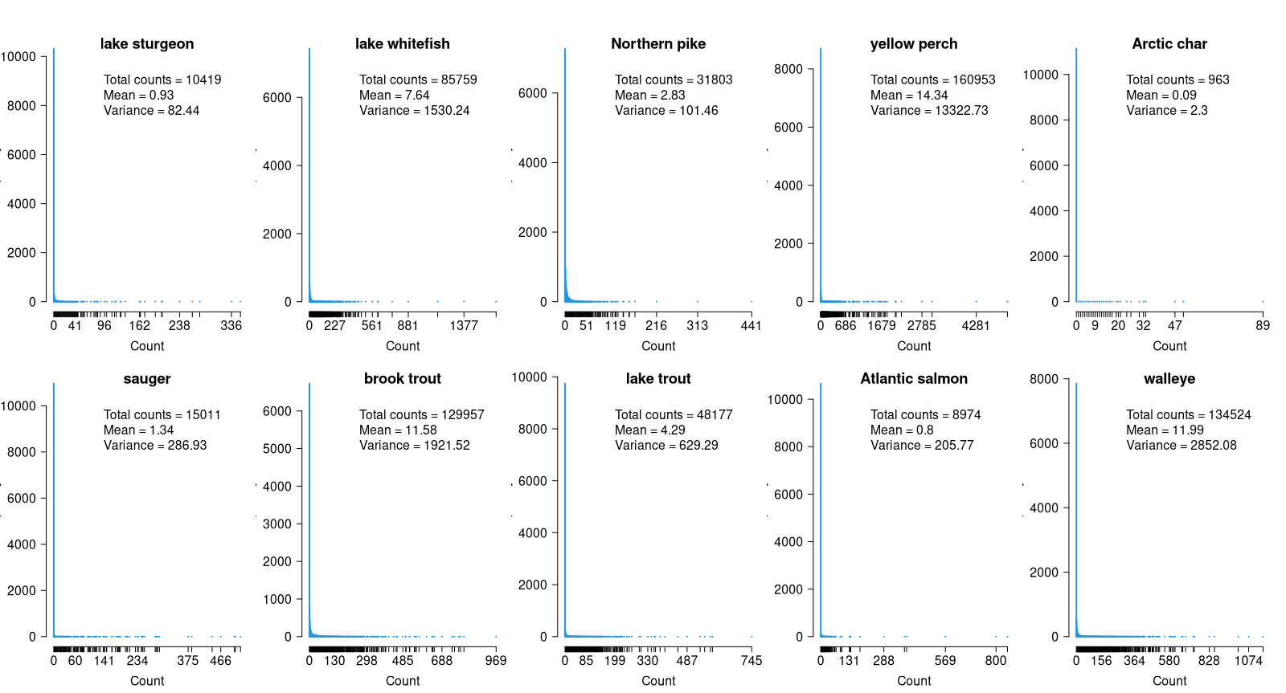

Figure S1. Distribution of abundance values of the ten focal species in our dataset. All species have heavily overdispersed distributions with a high proportion of zeros.

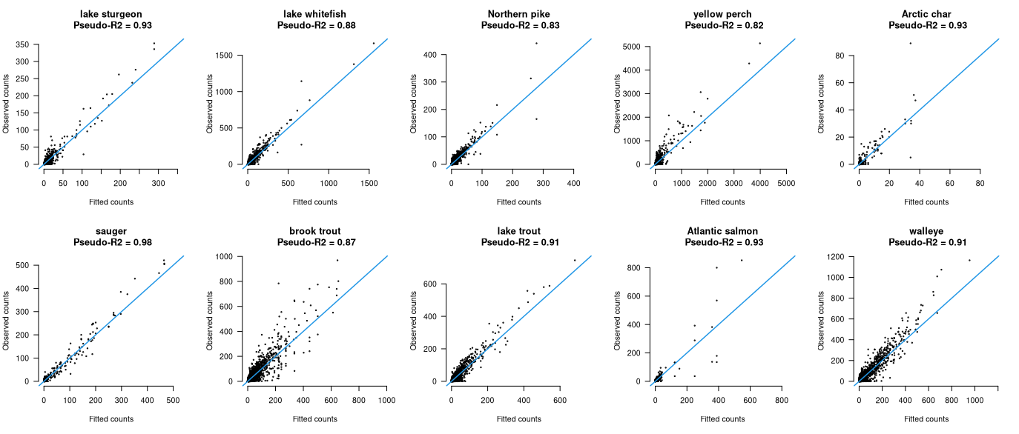

Figure S2. Pseudo-*R*2 and plots of observed abundance vs. predicted abundance for the ten species-specific XGBoost models. Blue lines represent 1:1 lines.

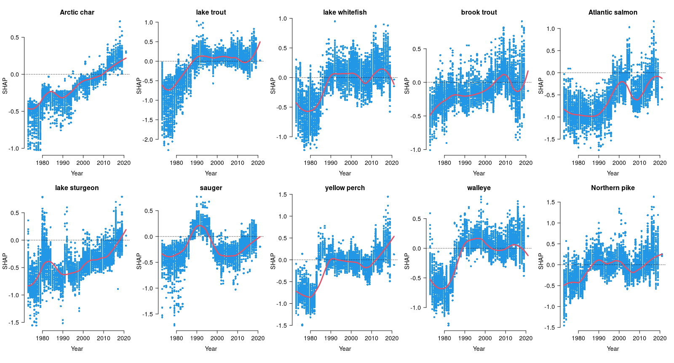

Figure S3. Dependence plots for year based on the SHAP values and fitted loess curves. The top row shows responses in the cold-water species (preferenda <16 °C) and the bottom row shows responses in cold/cool-water (lake sturgeon) and cool-water species (preferenda≥ 16 °C), all ordered by increasing temperature preferenda. Each point represents an individual observation (sampling site).