Article
Mineralogy and mineral chemistry of dioritic dykes, quartz diorite enclaves and pyroxene xenocrysts of the Sungun Cu-Mo porphyry deposit, East Azerbaijan, Iran
Amin Allah Kamali¹*, Moayyed, Mohsen², Saumur, Benoit M. ³ and Mohammad Fadaeian⁴
Citation: Kamali, A.A.; Lastname, F.; Lastname, F. Title. Crystals 2022, 12, x. https://doi.org/10.3390/xxxxx
Academic Editor: Firstname Lastname
Received: date
Accepted: date
Published: date
Publisher’s Note: MDPI stays neutral with regard to jurisdictional claims in published maps and institutional affiliations.
Copyright: © 2022 by the authors. Submitted for possible open access publication under the terms and conditions of the Creative Commons Attribution (CC BY) license (https://creativecommons.org/licenses/by/4.0/).
¹ Research Center for Conservation of Culture Relics (RCCCR), Research institute of Cultural Heritage & Tourism, Tehran, Iran; aminkamali1984@gmail.com
² Department of Geology, University of Tabriz, Tabriz 51664, Iran; Moayyed@tabrizu.ac.ir
³ Département des Sciences de la Terre et de l’Atmosphère, Université du Québec à Montréal, 201 avenue du Président-Kennedy, Case postale 8888, Succursale Centre-ville, Montréal, QC., H3C 3P8
⁴ Department of Geology, Payame Noor University, Tehran, Iran
* Correspondence: aminkamali1984@gmail.com
Abstract: The Sungun Cu-Mo porphyry deposit forms part of the Ahar-Arasbaran Magmatic Belt (AAMB). Its host Miocene porphyry stock is quartz monzonitic in composition and is cut by intermediate dykes that post-date mineralization. These dykes contain pyroxene xenocrysts and enclaves of ambiguous origin. Dykes of microdiorite are observed within quartz diorite dykes, whereas later diorite dykes contain three different kinds of enclaves (diorite, quartz diorite and hornfels) of sizes between 1 and 10 cm. Enclaves consist of plagioclase, hornblende and biotite, with accessory sphene, quartz and apatite. Chlorite compositions in microdiorite are within the chamosite range, whereas they are within the clinochlore range in diorite enclaves. Microprobe analyses of pyroxene xenocrysts indicate an augitic composition [Fs13.38-22.79Wo29.1-33.57En48.53-56.61], consistent with an igneous origin. Hornblende of the diorite enclaves formed at pressures ranging between of 3 and 5.3 kilobars, and temperatures between 714 to 731 °C. Average oxygen fugacity during rock formation is -14.75. Such high oxygen fugacties suggest that the diorite formed near the boundaries of a convergent margin. Amphibole compositions suggest that the diorite enclaves are sub-alkaline to mildly alkaline, consistent with reported whole rock chemistry of the Sungun magmas. Pyroxenes were formed at pressures ranging between 11 to 15 kilobars (33–45 km) and temperatures between 1100 to 1400 °C. The amount of Fe3+ in clinopyroxene is also consistent with high oxygen fugacity within their environment of crystallization. Overall these results have implications on our understanding of the origin of the Sungun Cu-Mo porphyry magmas and its mineral deposits in a lower-crustal setting.
Keywords: Enclave, Amphibole, pyroxene xenocrysts, Thermometry-barometry, Sungun

1. Introduction

Porphyry deposits, suppliers of ~75% of the world’s copper and significant proportions of Mo, Au, Re, are formed in subduction-related magmatic arcs [1] and, to some extent, in post-subduction collisional zones [2]. They are associated with magmas of intermediate to felsic composition (mostly andesitic to dacitic) having calc-alkaline to alkaline affinity [1]. In modern environments, porphyry-related deposits are usually found within active subduction zones, and in ancient environments these ores are associated with former collision zones [1,2]. The global distribution of known Cu-Au porphyry deposits shows a clear spatial relationship with volcanic arc terranes at convergent plate margins (e.g., [1,3]). The Sungun Cu-Mo porphyry deposit, which is the focus of this study, was formed in a post-collisional environment [4]. Studies of the Sungun plutonic rocks and deposit thus provide the opportunity to document petrological and geochemical controls that affect mineralization in such environments.

The Sungun Cu-Mo deposit, situated 32 km north of the Varzaghan, East Azerbaijan Province, is located within the Cenozoic Ahar-Arasbaran Magmatic Belt (AAMB) of northwestern Iran. The AAMB is part of the Alborz-Arasbaran-Lesser Caucasus Magmatic Belt, which resulted from the subduction and subsequent collision along the southern margin of Eurasia [5] (Fig.1). The AAMB hosts many world-class porphyry copper deposits, including the northwestern Sungun deposit which contains ore reserves of 740 Mt at 0.65 % Cu [6,7]. The host Cenozoic volcanic and plutonic rocks of this belt have medium to high-K, calc-alkaline to alkaline composition, and the deposits show common characteristics regarding their geology, host rocks, ages, alteration and mineralization [8–10]. A notable characteristic of Sungun is the presence of eight generations of dykes that cross-cut the deposit ([11-12]; and references therein), and these dykes are genetically linked to the magmatic-hydrothermal system that generated the deposit [4], and therefore may provide clues with regards to temperature-pressure conditions in the magmatic plumbing system.

Among the dyke generations observed at Sungun, diorite dykes (“Pulse 1” of [11]) contain several types of enclaves; these include enclaves of quartz diorite, diorite, microdiorite and hornfels, with the former three sharing mineralogical and geochemical characteristics with their host dykes. Pyroxene xenocrysts also occur within these dykes, yet are poorly understood from a petrogenic point of view. This paper aims to elucidate the source and genesis of the Sungun enclaves and pyroxene xenocrysts, and constrain physical and chemical conditions for their formation, (i.e., pressure, temperature, oxygen fugacity) based on field observations, petrographic features and mineral chemistry. Our results also have implications on our understanding of the genesis of the Sungun deposit, notably with respect to temperatures of alteration and the documentation of a number of magmatic episodes.

2. General Geology

The Oligocene Sungun porphyry has been the subject of several geological and metallogenic studies [4,13,14]. Dated at 20.69 and 21 Ma by Ar-Ar ad U-Pb (SHRIMP), respectively [15], it was emplaced within a 500 m thick sequence of folded upper Cretaceous limestone with intercalations of shale and Eocene volcaniclastic rocks and sandstones [13-14, 16]. Quartz monzonite, containing Cu-Mo mineralization, represents the earliest and most voluminous magmatic phase of the Sungun porphyry [12]. The interaction of the Sungun porphyry stock with surrounding Cretaceous limestone produced skarn zones in the northern and eastern periphery of the porphyry; this skarn contains clinopyroxene that was also analyzed in this study. Hornfels is usually observed along the edges of the eastern occurrences of skarn along topographic scars.

Alteration and mineralization are concentric and centered on the Sungun intrusion, and interpreted as coeval with its emplacement [8]. Documented hydrothermal alteration consists of an early phase of potassic and propylitic alteration. This early event is associated with the hypogene copper mineralization, precipitated as chalcopyrite and bornite, as both dissemination and veinlets. Molybdenite associated with quartz veins is associated with the early potassic event, but located within internal portions of the Sungun intrusion. These events were followed sequentially by phyllic, silicic and argillic stages of alteration.

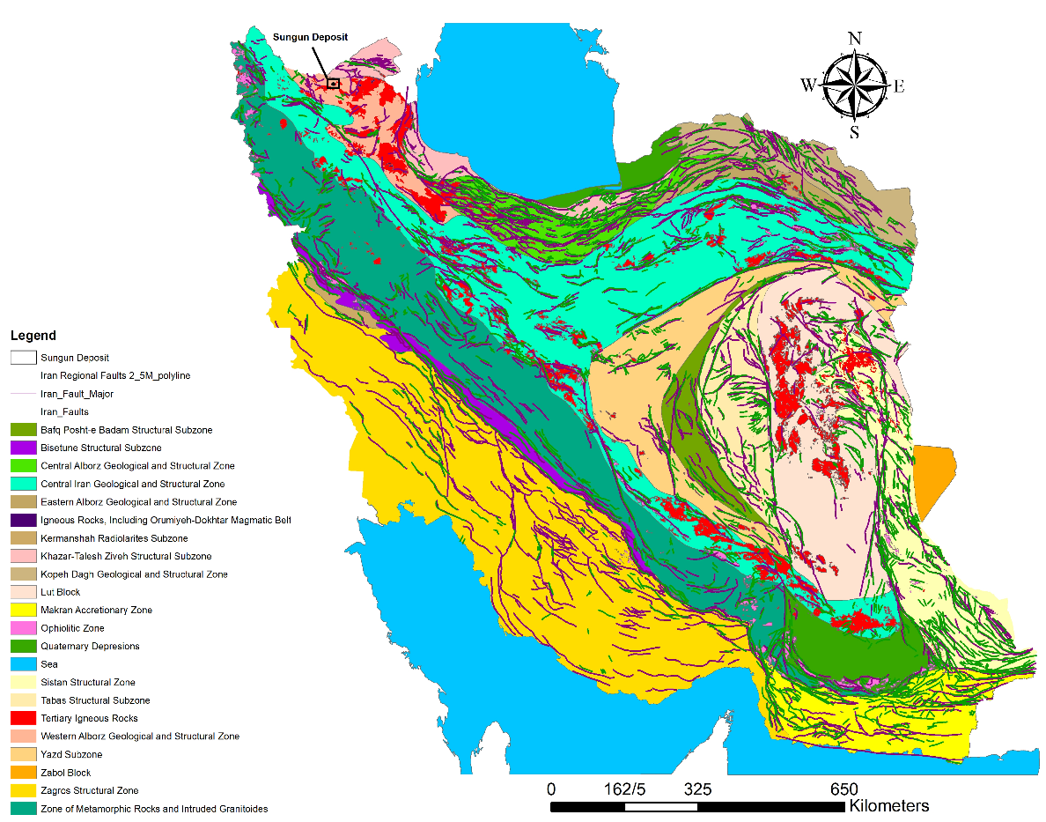
Figure 1. Regional tectonic map of Iran [17] showing the location of the study area.

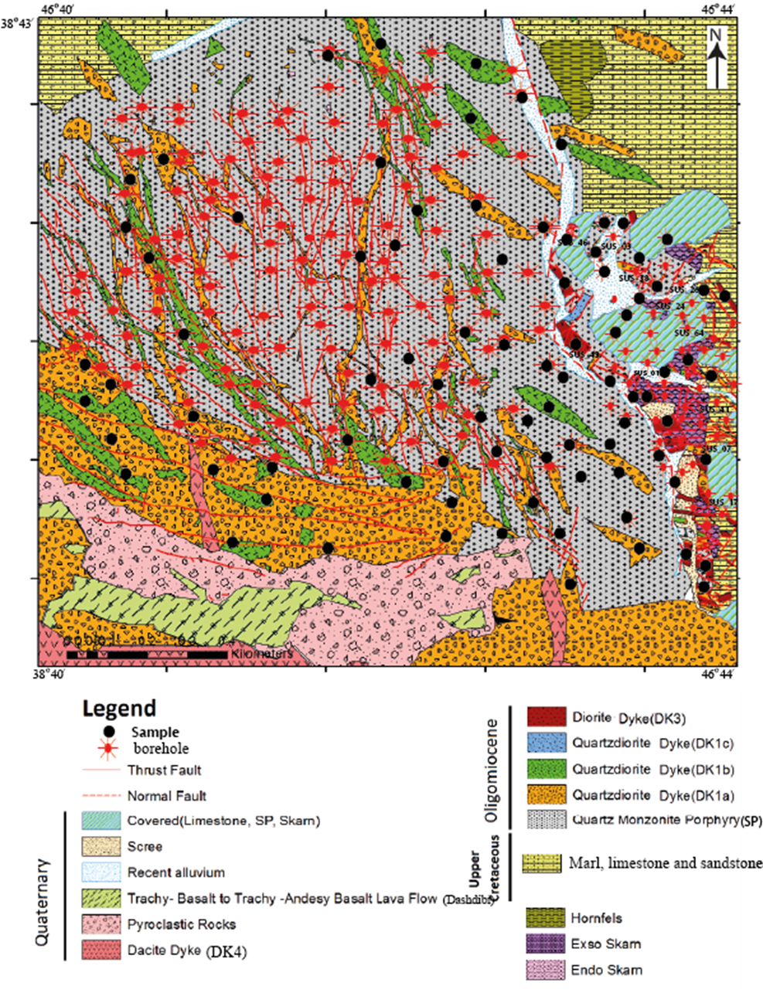
Figure 2. Geological map of the Sungun Copper Mine[11].

The initial phase of quartz monzonite magmatism was followed by pulses of diorite-granodiorite and, finally, andesitic magmatism [8,16]. This later activity is associated with the emplacement of multiple generations of dykes within both the voluminous quartz monzonite body and surrounding carbonate country rocks.

Previous geochemical studies show that the Sungun dykes and porphyry have a common origin, with bulk rock compositions more consistent with the post-collisional magmatic arc domain compared to magmas from continental active margins [4,11,14]. However, the dykes are compositionally slightly more mafic than the porphyry. ⁸⁷Sr/⁸⁶Sr and ¹⁴³Nd/¹⁴⁴Nd ratios for the porphyry and dykes, with the exception of microdiorite dykes, are consistent with a mantle source and closed-system fractionation. Thermobarometry of the dykes indicates that their magmas formed from the extraction of an intermediate magma and another magma of mixed crust-mantle affinity [11]. At a maximum pressure of 19 kbar, gravitational separation of the magmas within a lower-crustal magmatic chamber gave rise to a dioritic magma. This magma then rose and settled into another chamber at a maximum of 6 kbar (~18 km), where it fractionated and gravitationally separated. These magmas rose again in sequence, thereby creating the more felsic and earlier Sungun porphyry and the subsequent intermediate Sungun dykes [16,18].

Eight groups of post-mineralization dykes are defined at Sungun based on sequence of emplacement and relative ages; these cross-cutting relationships were documented during detailed field studies, core logging and the identification of sequences of alteration [11]. Four of these groups, forming part of the initial dyke-forming magma pulse, are relevant to this study: from oldest to youngest, these are the DK1a, DK1b and DK1c groups consisting of quartz diorite, and DK3 consisting of diorite. Based on age determinations by [9] and [15] the emplacement age for DK1a ranges between 20.57 and 19.85 Ma. DK1a and DK1b dykes contain microdiorite enclaves as well as DK1b autobreccia (Fig. 3a and 3c). DK1c dykes have been observed in pit section of boreholes, but it is exhalant in the eastern skarn section of the mine. DK3 dykes contain abundant hornfels enclaves and autoliths (Fig. 3e and 3g).

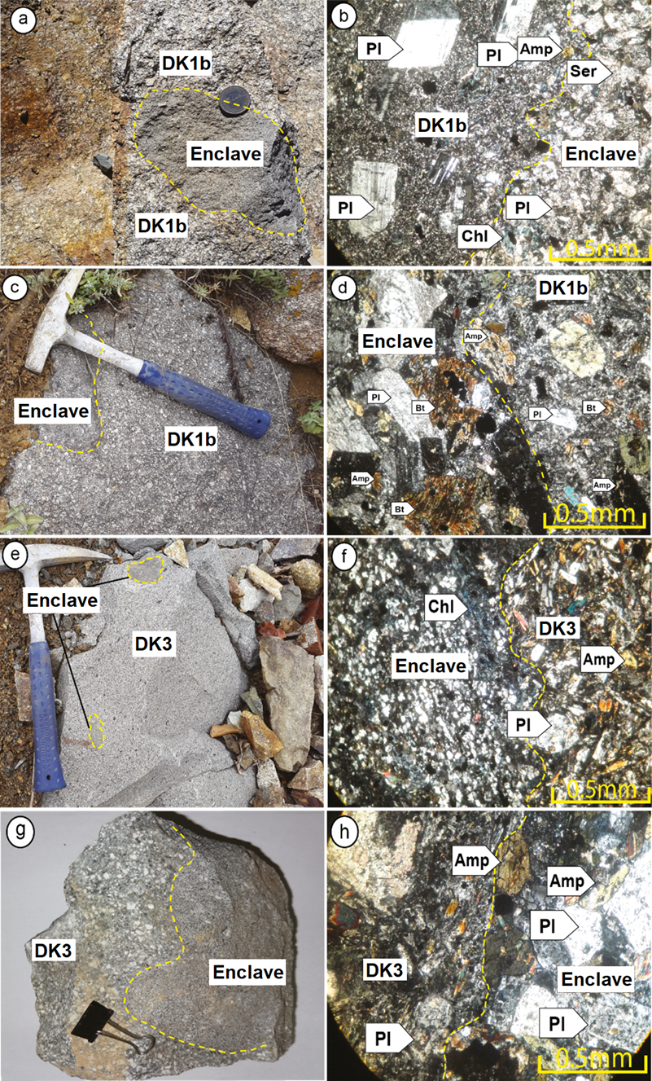

Figure 3. Hand sample (left) and thin section (right) photographs of representative samples from Sungun post-mineralization dykes. All photomicrographs are in plane polarized light. a-b) Microdiorite enclaves in DK1b dykes: a) Mingled contact between a fine-grained micro diorite sheet and a medium-grained quartz diorite. b) Photomicrograph showing the contact between the micro diorite and a quartz diorite. c-d) Quartz diorite enclaves: c) Irregular mingled contact between a fine-grained otoliths autoliths and a medium-grained quartz diorite. d) the boundary between the quartz diorite and its enclave. E-f) Hornfels enclaves in DK3 dykes: e) Hornfels xenolith within an outcrop of fine-grained diorite. f) Photomicrograph showing the boundary between the dyke and enclave of hornfels in microscopic scale. g-h) Diorite enclaves in DK3 dykes: g) DK3 xenolith in the dioritic dykes. h) Photomicrograph of the contact of DK3 xenolith with the host diorite dyke.

3. Materials and Methods

Preparation and field operations, sampling and laboratory studies were completed in the autumn and winter of 2013. Petrographic studies were performed using a BX53-P - CX31-P OLYMPUS polarizing microscope.

Geochemical studies of various silicate minerals, such as plagioclase, amphibole, pyroxene and chlorite, were carried out in the laboratory of the Iranian Mineral Research and Technology Center (Imidro) and the Microprobe Laboratory of the University of Oklahoma, USA, using a CAMECA SX100 device (20 kV, 20 nA, 2mm spot).

4. Petrography

4.1. Dykes

DK1b dykes (quartz diorite): The main minerals observed in quartz diorite dykes are plagioclase, biotite and amphibole. Plagioclase shows swinging zoning and polysynthetic twins, and crystal rims exhibit sericite alteration (Fig. 3b). Amphibole is observed as fine- to coarse- grained subhedral to euhedral crystals. Biotite has a weak to strong alteration, and in some cases has been completely sericitized and chloritized. Dk1b dykes can contain enclaves of microdiorite, which are described in the following section.

DK3 dykes (diorite): These dark green diorites contain unaltered white plagioclase phenocrysts and amphibole (Fig. 4a), and exhibit a microlithic porphyritic to coarsely porphyritic texture (Fig. 4f). Crystal sizes vary from fine to coarse, plagioclase is subhedral and locally contains sieve texture and swinging zoning (Fig. 4b). Amphiboles are subhedral to euhedral and are locally replaced by chlorite, epidote and sericite (Fig. 4d), which, in order, represents a typical alteration sequence. Orthoclase, quartz, sphene, apatite and opaque minerals are minor constituents., Diorite dykes can contain large clinopyroxene (augite) xenocrysts. These occur as coarse, subhedral to euhedral crystals, and in some microscopic sections, augite crystals exhibit exsolution features (Fig 4, e and f). DK3 dykes may also contain large enclaves of hornfels and diorite, described below.

4.2. Enclaves

Microdiorite enclaves in DK1b dykes: Enclaves of microdiorite are porphyritic to microlithic, often gray in color in hand sample, and are mesocratic to melanocratic. The diameter of these enclaves ranges between 2 to 10 centimeters (Fig. 3a). Plagioclase and ferromagnesian minerals form the bulk of the mineralogy. Plagioclase occurs as euhedral to subhedral phenocrysts with polysynthetic twinning, and is often moderately to strongly altered to saussurite (Fig. 3b). Such crystals form 30-40 modal % of the rock. Ferromagnesian minerals do not occur as phenocrysts and have been completely chloritized and carbonated (Fig. 3b). The fine-grained matrix forms 40% to 50% of the rock, but its primary mineralogy is not recognizable due to extreme alteration.

Diorite enclaves in DK3 dykes: These enclaves show the same overall mineralogy as the host DK3 diorite dykes. Hand samples of these enclaves are often dark gray, have sizes ranging between 2 to 7 centimeters and show granular textures (Fig. 3g). Plagioclase often occurs as medium to coarse, subhedral to euhedral crystals that have sustained chlorite and epidote alteration (Fig. 3h). Apatite, quartz, sphene and opaques are accessory minerals.

DK1b enclaves in DK3 dykes: Quartz diorite enclaves are granular-textured, exhibit sizes ranging between 3 to 10 centimeters (Fig. 3d), and hand samples are often gray in color. Chilled contacts of these enclaves with quartz diorite (DK1b) are clearly visible. Main minerals include plagioclase, amphibole and biotite. Plagioclase is observed as euhedral to subhedral, medium to coarse-grained crystals, has polysynthetic twinning, exhibits poikilitic texture and has sustained moderate alteration. It forms a cumulate phase in some samples, forming up to 65 modal % of one particular enclave (Fig 3d). Amphibole (25-35% modal) is observed as fine to coarse, euhedral to subhedral crystals exhibiting simple twinning, and is only moderately altered. This mineral forms 25 to 35 % of this type of enclave and has sustained moderate alteration (Fig. 3d). Biotite (10%) is observed as medium to coarse crystals, is euhedral to subhedral and, has sustained weak alteration. Biotite also locally forms coronae around poikilitic plagioclase (Fig. 3d). Apatite and quartz are accessory phases.

Hornfels enclaves in DK3 dykes: Hand samples of hornfels enclaves are gray, very hard and dense. The size of these enclaves ranges between a few millimeters up to about 5 centimeters (Fig. 3f). They are fine grained and contain quartz, hornblende, epidote, chlorite, plagioclase and opaque minerals. Epidotized plagioclase and hornblende has also been chloritized (Fig. 3f). Mineral assemblages are consistent with metamorphism in the Hornblende Hornfels facies.

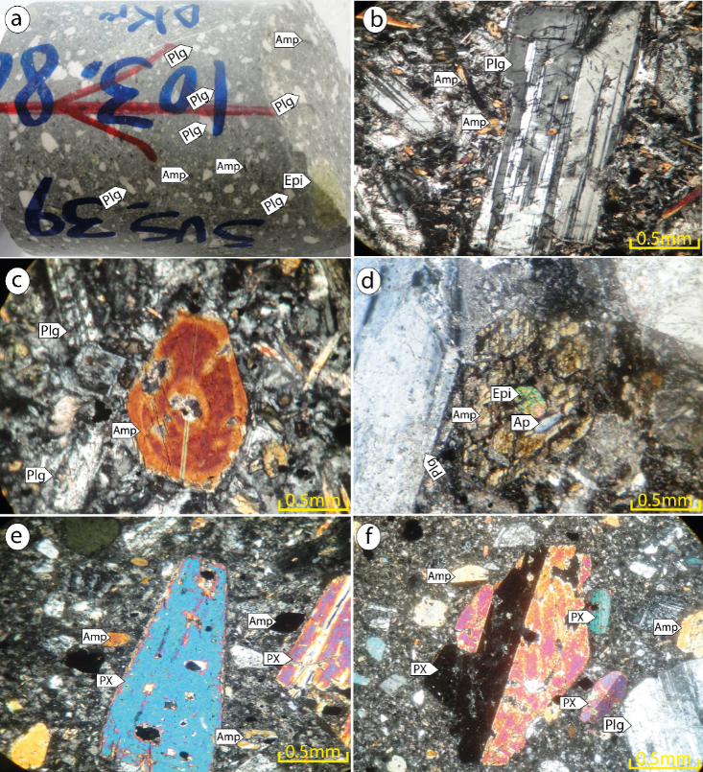

Figure 4. a) A hand specimen from the dioritic dykes (coarse plagioclase (plg), epidote (Epi) and amphibole (Amp)); b) Plagioclase phenocrysts exhibiting twinning; c) euhedral amphiboles and plagioclase. d) Alteration of amphibole and plagioclase in diorite dykes; e and f) Pyroxene xenocrysts in diorite dykes (DK3).

5. Mineral Chemistry of Microdiorite and Diorite Enclaves

5.1. Plagioclase chemistry

The results of EPMA of plagioclase are shown in Table 1, based on 5 cations and 8 oxygen atoms. In all samples plagioclase is highly sodic albite, although some slightly calcic grains from microdiorite enclaves plot as oligoclase (Fig 5). The An content for plagioclase from microdiorite enclaves varies between 2.73% to 15.07%, and that for the diorite enclaves between 2.88% and 4.89%. Average values are 7.89% and 3.82%, respectively. The composition of plagioclase in the quartz diorite dykes (DK1a, DK1b and DK1c) varies from albite-oligoclase to andesine and oligoclase to andesine; in the diorite, it varies from andesine to labradorite; in the LAM, from albite to oligoclase; and in the microdiorite (MDI), it occurs as albite [11].

Table 1. Representative analyses of plagioclase from diorite and micro diorite enclaves
Xen-DK1b |  |  |  |  |  |  |  |  |  | Xen -DK3
Sample | Pl1 | Pl2 | Pl3 | Pl4 | 1* | 2* | 3* | 4* | 5* | 1* | 2* | 3* | 4* | 5* | 6 | 7 | 8 | 9
SiO₂ | 67.28 | 65.11 | 66 | 66.76 | 64.14 | 66.06 | 67.41 | 67.46 | 66.87 | 67.35 | 66.44 | 67.62 | 66.78 | 66.43 | 66.82 | 67.26 | 64.11 | 67.33
TiO₂ | 0.02 | 0 | 0.03 | 0 | 0 | 0.03 | 0.01 | 0 | 0 | 0 | 0 | 0.02 | 0.05 | 0.05 | 0.02 | 0.02 | 0.08 | 0.03
Al₂O₃ | 20.65 | 21.47 | 21.37 | 20.73 | 22.03 | 20.53 | 20.18 | 20.04 | 21.21 | 20.31 | 20.56 | 19.96 | 20 | 20.17 | 20.25 | 19.91 | 20.35 | 20.28
Cr₂O₃ | 0 | 0 | 0 | 0 | 0 | 0 | 0 | 0 | 0 | 0 | 0 | 0 | 0 | 0 | 0 | 0 | 0 | 0
FeO | 0.04 | 0.03 | 0.03 | 0.03 | 0.09 | 0.04 | 0.03 | 0.02 | 0.05 | 0.33 | 0.39 | 0.35 | 0.3 | 0.36 | 0.4 | 0.13 | 2.92 | 0.23
MnO | 0 | 0.01 | 0.02 | 0.01 | 0 | 0.02 | 0 | 0 | 0.01 | 0.03 | 0.02 | 0.03 | 0.01 | 0 | 0.02 | 0 | 0.05 | 0.02
MgO | 0 | 0 | 0.01 | 0.01 | 0.02 | 0.01 | 0 | 0 | 0.01 | 0 | 0.01 | 0 | 0 | 0 | 0.04 | 0 | 0.64 | 0.08
CaO | 1.32 | 2.32 | 1.82 | 1.71 | 3.18 | 1.32 | 0.85 | 0.58 | 1.82 | 0.61 | 0.83 | 0.61 | 0.63 | 0.97 | 0.98 | 0.7 | 0.86 | 0.87
Na₂O | 10.71 | 10.32 | 10.48 | 10.69 | 9.74 | 10.69 | 11.01 | 11.32 | 10.44 | 10.69 | 9.99 | 11.18 | 10.93 | 10.89 | 10.21 | 10.47 | 10.87 | 10.93
K₂O | 0.15 | 0.09 | 0.07 | 0.08 | 0.25 | 0.1 | 0.12 | 0.1 | 0.13 | 0.63 | 0.58 | 0.17 | 0.32 | 0.2 | 0.42 | 0.19 | 0.15 | 0.38
Total | 100.17 | 99.35 | 99.82 | 100.02 | 99.45 | 98.81 | 99.62 | 99.54 | 100.53 | 99.96 | 98.82 | 99.94 | 99.02 | 99.07 | 99.16 | 98.68 | 100.03 | 100.15
Formula 8 (O)
Si | 2.94 | 2.88 | 2.9 | 2.93 | 2.85 | 2.93 | 2.96 | 2.96 | 2.92 | 2.96 | 2.94 | 2.96 | 2.96 | 2.94 | 2.95 | 2.97 | 2.86 | 2.95
Ti | 0 | 0 | 0 | 0 | 0 | 0 | 0 | 0 | 0 | 0 | 0 | 0 | 0 | 0 | 0 | 0 | 0 | 0
Al | 1.06 | 1.12 | 1.11 | 1.07 | 1.15 | 1.07 | 1.04 | 1.04 | 1.09 | 1.05 | 1.07 | 1.03 | 1.04 | 1.05 | 1.05 | 1.04 | 1.07 | 1.05
Cr | 0 | 0 | 0 | 0 | 0 | 0 | 0 | 0 | 0 | 0 | 0 | 0 | 0 | 0 | 0 | 0 | 0 | 0
Fe2+ | 0 | 0 | 0 | 0 | 0 | 0 | 0 | 0 | 0 | 0.01 | 0.01 | 0.01 | 0.01 | 0.01 | 0.01 | 0 | 0.11 | 0.01
Mn | 0 | 0 | 0 | 0 | 0 | 0 | 0 | 0 | 0 | 0 | 0 | 0 | 0 | 0 | 0 | 0 | 0 | 0
Mg | 0 | 0 | 0 | 0 | 0 | 0 | 0 | 0 | 0 | 0 | 0 | 0 | 0 | 0 | 0 | 0 | 0.04 | 0.01
Ca | 0.06 | 0.11 | 0.09 | 0.08 | 0.15 | 0.06 | 0.04 | 0.03 | 0.08 | 0.03 | 0.04 | 0.03 | 0.03 | 0.05 | 0.05 | 0.03 | 0.04 | 0.04
Na | 0.91 | 0.89 | 0.89 | 0.91 | 0.84 | 0.92 | 0.94 | 0.96 | 0.88 | 0.91 | 0.86 | 0.95 | 0.94 | 0.94 | 0.87 | 0.9 | 0.94 | 0.93
K | 0.01 | 0 | 0 | 0 | 0.01 | 0.01 | 0.01 | 0.01 | 0.01 | 0.04 | 0.03 | 0.01 | 0.02 | 0.01 | 0.02 | 0.01 | 0.01 | 0.02
Total | 4.98 | 5 | 4.99 | 4.99 | 5 | 5 | 4.99 | 5 | 4.98 | 4.99 | 4.97 | 5 | 5 | 5 | 4.97 | 4.96 | 5.08 | 5
Ab | 92.86 | 88.52 | 90.88 | 91.48 | 83.51 | 93.07 | 95.22 | 96.67 | 90.57 | 93.43 | 92.2 | 96.16 | 95.13 | 94.22 | 92.59 | 95.35 | 94.97 | 93.72
Or | 0.84 | 0.48 | 0.41 | 0.46 | 1.42 | 0.59 | 0.69 | 0.59 | 0.72 | 3.64 | 3.54 | 0.96 | 1.86 | 1.14 | 2.52 | 1.13 | 0.87 | 2.14
An | 6.3 | 11 | 8.71 | 8.07 | 15.07 | 6.34 | 4.08 | 2.74 | 8.71 | 2.93 | 4.26 | 2.88 | 3.01 | 4.64 | 4.89 | 3.52 | 4.16 | 4.14

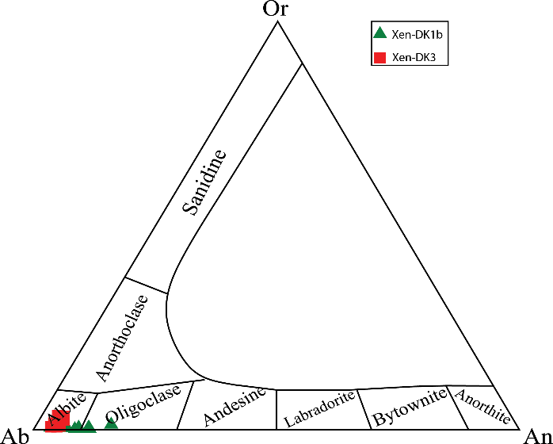

Figure 5. Plagioclase phenocryst compositions for each of the diorite and micro diorite enclaves[19].

5.2. Chlorite chemistry

Chemical analyses of chlorite, together with the calculated unit cell formulae, are presented in Table 2 (based 14 oxygen atoms), and compositions are plotted in Figure 6. In the Fe/ (Mg+Fe²⁺) - Al^{IV}/ (Si+Al^{IV}) diagram, chlorite of microdiorite and diorite enclaves are located in the aluminum Al-chamosite and Al-Fe clinochlore range, respectively (Fig. 6a). Also, in the Si - Mg/ (Mg+Fe) diagram, which isolates clinochlore and chamozite endmember compositions, samples of diorite and microdioritic enclaves are, respectively, located within the clinochlore and chamozite range (Fig. 6b).The chemical composition of the chlorite in the quartz diorite (DK1a and DK1b), diorite (DK3) and MDI dykes falls in the range of pycnochlorite field, and in the dyke DK1c it is within the pennine field [11].

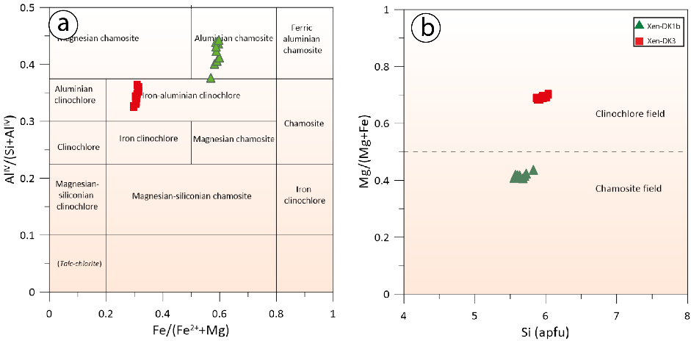

Figure 6. Compositional variations of chlorites in terms of .a) Fe/ (Mg+Fe2+) versus AlIV/ (Si+Al^{IV})[20]. b) Mg/ (Mg+ Fe) versus Si [21] from diorite and micro diorite enclaves (cations/28 oxygen atoms).

Table 2. Representative major-element compositions of chlorite from studied diorite and micro diorite enclaves
Xen-DK1b |  |  |  |  |  |  |  |  |  |  | Xen-DK3
Sample | b1 | b2 | b3 | b4 | b5 | b6 | b7 | b8 | b9 | b10 | k1 | k2 | k3 | k4 | k5 | k6 | k7 | k8 | k9 | k10 | k11 | k12 | k13 | k14 | k15
SiO2 | 25.43 | 26.45 | 26.25 | 26.30 | 26.14 | 26.06 | 25.61 | 27.01 | 25.90 | 25.59 | 29.41 | 29.20 | 29.42 | 29.20 | 28.95 | 28.97 | 29.05 | 29.07 | 28.48 | 28.95 | 28.67 | 30.15 | 29.00 | 28.91 | 28.75
TiO2 | 0.04 | 0.04 | 0.01 | 0.03 | 0.07 | 0.09 | 0.02 | 0.05 | 0.03 | 0.08 | 0.01 | 0.02 | 0.00 | 0.03 | 0.01 | 0.01 | 0.01 | 0.02 | 0.02 | 0.01 | 0.00 | 0.02 | 0.00 | 0.02 | 0.01
Al2O3 | 19.14 | 18.67 | 18.53 | 18.82 | 18.83 | 19.12 | 19.27 | 17.85 | 19.39 | 19.68 | 18.59 | 18.69 | 18.57 | 18.60 | 18.85 | 18.13 | 17.83 | 18.20 | 18.26 | 17.73 | 18.02 | 18.23 | 17.34 | 18.83 | 18.66
FeO | 30.21 | 29.93 | 30.46 | 31.02 | 30.67 | 30.26 | 30.11 | 29.73 | 30.15 | 30.32 | 16.84 | 16.87 | 16.62 | 17.03 | 17.32 | 16.74 | 16.67 | 16.63 | 16.97 | 16.50 | 16.69 | 16.57 | 16.09 | 17.16 | 17.04
MnO | 0.58 | 0.54 | 0.54 | 0.58 | 0.57 | 0.58 | 0.56 | 0.52 | 0.56 | 0.59 | 0.46 | 0.46 | 0.43 | 0.52 | 0.51 | 0.49 | 0.49 | 0.49 | 0.50 | 0.47 | 0.48 | 0.48 | 0.50 | 0.47 | 0.47
MgO | 11.48 | 12.03 | 11.80 | 11.63 | 11.49 | 11.85 | 11.88 | 12.60 | 11.84 | 11.44 | 21.28 | 21.15 | 21.33 | 21.22 | 21.12 | 21.04 | 21.10 | 21.40 | 20.69 | 20.98 | 20.94 | 22.11 | 21.35 | 21.46 | 20.98
CaO | 0.06 | 0.08 | 0.18 | 0.06 | 0.07 | 0.12 | 0.13 | 0.14 | 0.10 | 0.07 | 0.16 | 0.14 | 0.15 | 0.15 | 0.15 | 0.15 | 0.14 | 0.12 | 0.10 | 0.15 | 0.17 | 0.17 | 0.15 | 0.15 | 0.14
K2O | 0.00 | 0.01 | 0.01 | 0.01 | 0.00 | 0.01 | 0.00 | 0.01 | 0.01 | 0.00 | 0.02 | 0.01 | 0.01 | 0.01 | 0.01 | 0.01 | 0.01 | 0.00 | 0.01 | 0.01 | 0.02 | 0.02 | 0.01 | 0.01 | 0.02
F | 0.00 | 0.00 | 0.00 | 0.00 | 0.06 | 0.00 | 0.03 | 0.00 | 0.00 | 0.14 | 0.09 | 0.04 | 0.24 | 0.17 | 0.07 | 0.17 | 0.04 | 0.09 | 0.18 | 0.11 | 0.26 | 0.35 | 0.03 | 0.12 | 0.03
Cl | 0.01 | 0.00 | 0.01 | 0.01 | 0.01 | 0.00 | 0.01 | 0.00 | 0.01 | 0.01 | 0.00 | 0.00 | 0.00 | 0.01 | 0.00 | 0.00 | 0.00 | 0.00 | 0.01 | 0.01 | 0.01 | 0.00 | 0.00 | 0.01 | 0.00
O=F | 0.00 | 0.00 | 0.00 | 0.00 | 0.03 | 0.00 | 0.01 | 0.00 | 0.00 | 0.06 | 0.04 | 0.02 | 0.10 | 0.07 | 0.03 | 0.07 | 0.02 | 0.04 | 0.08 | 0.05 | 0.11 | 0.15 | 0.01 | 0.05 | 0.01
O=Cl | 0.00 | 0.00 | 0.00 | 0.00 | 0.00 | 0.00 | 0.00 | 0.00 | 0.00 | 0.00 | 0.00 | 0.00 | 0.00 | 0.00 | 0.00 | 0.00 | 0.00 | 0.00 | 0.00 | 0.00 | 0.00 | 0.00 | 0.00 | 0.00 | 0.00
Total | 86.95 | 87.75 | 87.79 | 88.46 | 87.88 | 88.09 | 87.61 | 87.91 | 87.99 | 87.86 | 86.82 | 86.56 | 86.67 | 86.87 | 86.96 | 85.64 | 85.32 | 85.98 | 85.14 | 84.87 | 85.15 | 87.95 | 84.46 | 87.09 | 86.09
14(O)
Si | 2.79 | 2.86 | 2.85 | 2.84 | 2.84 | 2.81 | 2.78 | 2.91 | 2.80 | 2.78 | 2.98 | 2.97 | 2.99 | 2.97 | 2.94 | 2.98 | 3.00 | 2.98 | 2.96 | 3.00 | 2.97 | 3.02 | 3.02 | 2.93 | 2.95
Ti | 0.00 | 0.00 | 0.00 | 0.00 | 0.01 | 0.01 | 0.00 | 0.00 | 0.00 | 0.01 | 0.00 | 0.00 | 0.00 | 0.00 | 0.00 | 0.00 | 0.00 | 0.00 | 0.00 | 0.00 | 0.00 | 0.00 | 0.00 | 0.00 | 0.00
Al | 2.47 | 2.38 | 2.37 | 2.39 | 2.41 | 2.43 | 2.47 | 2.27 | 2.47 | 2.52 | 2.22 | 2.24 | 2.22 | 2.23 | 2.26 | 2.20 | 2.17 | 2.20 | 2.23 | 2.17 | 2.20 | 2.15 | 2.13 | 2.25 | 2.25
Fe(2+) | 2.77 | 2.71 | 2.76 | 2.80 | 2.78 | 2.73 | 2.74 | 2.68 | 2.72 | 2.75 | 1.43 | 1.43 | 1.41 | 1.45 | 1.47 | 1.44 | 1.44 | 1.42 | 1.47 | 1.43 | 1.45 | 1.39 | 1.40 | 1.46 | 1.46
Mn | 0.05 | 0.05 | 0.05 | 0.05 | 0.05 | 0.05 | 0.05 | 0.05 | 0.05 | 0.05 | 0.04 | 0.04 | 0.04 | 0.04 | 0.04 | 0.04 | 0.04 | 0.04 | 0.04 | 0.04 | 0.04 | 0.04 | 0.04 | 0.04 | 0.04
Mg | 1.88 | 1.94 | 1.91 | 1.87 | 1.86 | 1.91 | 1.92 | 2.02 | 1.91 | 1.85 | 3.22 | 3.21 | 3.23 | 3.21 | 3.20 | 3.23 | 3.25 | 3.27 | 3.20 | 3.25 | 3.24 | 3.30 | 3.31 | 3.24 | 3.21
Ca | 0.01 | 0.01 | 0.02 | 0.01 | 0.01 | 0.01 | 0.02 | 0.02 | 0.01 | 0.01 | 0.02 | 0.02 | 0.02 | 0.02 | 0.02 | 0.02 | 0.02 | 0.01 | 0.01 | 0.02 | 0.02 | 0.02 | 0.02 | 0.02 | 0.02
K | 0.00 | 0.00 | 0.00 | 0.00 | 0.00 | 0.00 | 0.00 | 0.00 | 0.00 | 0.00 | 0.00 | 0.00 | 0.00 | 0.00 | 0.00 | 0.00 | 0.00 | 0.00 | 0.00 | 0.00 | 0.00 | 0.00 | 0.00 | 0.00 | 0.00
F | 0.00 | 0.00 | 0.00 | 0.00 | 0.02 | 0.00 | 0.01 | 0.00 | 0.00 | 0.05 | 0.03 | 0.01 | 0.08 | 0.06 | 0.02 | 0.06 | 0.01 | 0.03 | 0.06 | 0.04 | 0.09 | 0.11 | 0.01 | 0.04 | 0.01
Cl | 0.00 | 0.00 | 0.00 | 0.00 | 0.00 | 0.00 | 0.00 | 0.00 | 0.00 | 0.00 | 0.00 | 0.00 | 0.00 | 0.00 | 0.00 | 0.00 | 0.00 | 0.00 | 0.00 | 0.00 | 0.00 | 0.00 | 0.00 | 0.00 | 0.00
Al(IV) | 1.21 | 1.14 | 1.15 | 1.16 | 1.16 | 1.19 | 1.22 | 1.09 | 1.20 | 1.22 | 1.02 | 1.03 | 1.01 | 1.03 | 1.06 | 1.02 | 1.00 | 1.02 | 1.04 | 1.00 | 1.03 | 0.98 | 0.98 | 1.07 | 1.05
Al(VI) | 1.26 | 1.24 | 1.22 | 1.23 | 1.25 | 1.25 | 1.25 | 1.18 | 1.27 | 1.29 | 1.20 | 1.21 | 1.21 | 1.19 | 1.20 | 1.18 | 1.17 | 1.17 | 1.19 | 1.17 | 1.18 | 1.16 | 1.14 | 1.18 | 1.20

5.3. Amphibole chemistry

Amphibole is one of the most abundant and important minerals in the dioritic enclaves of the region. In this study, their chemical composition is calculated based on 13 minerals and 23 cations (Table 3). The studied amphiboles from enclaves, based on the XXXXX diagram of [22], are located in the calcic group based on (Na+K)>0.5, Ca>1.5 and Ti<0.5, as well as within the sub-group of magnesiohornblende (Fig. 7a). Figure 7b shows Ti changes in relation to Al^{IV} for amphibole that have less than 0.5 Ti atoms in their structural formula. In this diagram, amounts of Al^{IV} and Ti are reduced in the structural formula of because of higher Si contents. In vector diagrams of edenite, pargasite and hornblende substitution, analyzed samples show evidence for hornblende-pargasite replacement (Fig. 7c). The amphibole in the Sungun dykes are a combination of hornblende-tschermakite and ferrotschermakite[11].

Table 3. Representative major-element compositions of amphibole from studied diorite enclave
Sample | X1 | X2 | X3 | X4 | X5 | X6 | X7 | X8 | X9 | X10
SiO2 | 43.16 | 45.19 | 45.20 | 46.15 | 46.41 | 44.63 | 45.26 | 46.06 | 44.38 | 45.36
TiO2 | 2.10 | 1.81 | 1.84 | 1.52 | 1.62 | 1.72 | 1.69 | 1.57 | 1.83 | 1.61
Al2O3 | 10.13 | 8.79 | 8.63 | 7.57 | 7.45 | 9.07 | 8.76 | 8.29 | 9.19 | 8.39
FeO | 12.95 | 12.38 | 12.23 | 11.72 | 11.44 | 12.54 | 12.48 | 12.49 | 12.80 | 12.47
MnO | 0.34 | 0.36 | 0.42 | 0.33 | 0.30 | 0.35 | 0.32 | 0.33 | 0.36 | 0.34
MgO | 14.03 | 15.17 | 15.09 | 15.68 | 16.08 | 14.84 | 14.98 | 15.39 | 14.21 | 15.01
CaO | 10.83 | 10.78 | 10.79 | 10.68 | 10.76 | 10.69 | 10.71 | 10.72 | 10.88 | 10.64
Na2O | 1.85 | 1.70 | 1.66 | 1.48 | 1.55 | 1.75 | 1.66 | 1.62 | 1.71 | 1.58
K2O | 0.62 | 0.53 | 0.54 | 0.45 | 0.46 | 0.58 | 0.58 | 0.53 | 0.61 | 0.57
Total | 98.07 | 98.80 | 98.48 | 97.65 | 98.16 | 98.25 | 98.52 | 99.10 | 98.03 | 98.04
 |  |  |  |  | T
Si | 6.28 | 6.49 | 6.51 | 6.68 | 6.67 | 6.45 | 6.52 | 6.59 | 6.46 | 6.57
Al | 1.72 | 1.49 | 1.47 | 1.29 | 1.26 | 1.55 | 1.48 | 1.40 | 1.54 | 1.43
Ti | 0.00 | 0.03 | 0.02 | 0.03 | 0.07 | 0.01 | 0.00 | 0.02 | 0.00 | 0.00
Total | 8.00 | 8.00 | 8.00 | 8.00 | 8.00 | 8.00 | 8.00 | 8.00 | 8.00 | 8.00
 |  |  |  |  | C
Al | 0.01 | 0.00 | 0.00 | 0.00 | 0.00 | 0.00 | 0.01 | 0.00 | 0.03 | 0.00
Ti | 0.23 | 0.17 | 0.18 | 0.13 | 0.11 | 0.18 | 0.18 | 0.15 | 0.20 | 0.17
Fe3+ | 1.43 | 1.38 | 1.33 | 1.27 | 1.29 | 1.40 | 1.33 | 1.34 | 1.29 | 1.32
Mg | 3.04 | 3.25 | 3.24 | 3.38 | 3.45 | 3.20 | 3.22 | 3.28 | 3.08 | 3.24
Fe2+ | 0.15 | 0.11 | 0.15 | 0.14 | 0.08 | 0.12 | 0.18 | 0.15 | 0.27 | 0.19
Mn2+ | 0.04 | 0.04 | 0.05 | 0.04 | 0.04 | 0.04 | 0.04 | 0.04 | 0.04 | 0.04
Total | 4.90 | 4.95 | 4.95 | 4.97 | 4.96 | 4.94 | 4.95 | 4.96 | 4.92 | 4.96
 |  |  |  |  | B
Ca | 1.69 | 1.66 | 1.67 | 1.66 | 1.66 | 1.66 | 1.65 | 1.64 | 1.70 | 1.65
Na | 0.31 | 0.34 | 0.33 | 0.35 | 0.34 | 0.35 | 0.35 | 0.36 | 0.30 | 0.35
Total | 2.00 | 2.00 | 2.00 | 2.00 | 2.00 | 2.00 | 2.00 | 2.00 | 2.00 | 2.00
 |  |  |  |  | A
Na | 0.21 | 0.13 | 0.13 | 0.07 | 0.09 | 0.15 | 0.12 | 0.09 | 0.18 | 0.09
K | 0.12 | 0.10 | 0.10 | 0.08 | 0.08 | 0.11 | 0.11 | 0.10 | 0.11 | 0.11
Total | 0.33 | 0.23 | 0.23 | 0.15 | 0.17 | 0.25 | 0.22 | 0.19 | 0.29 | 0.20

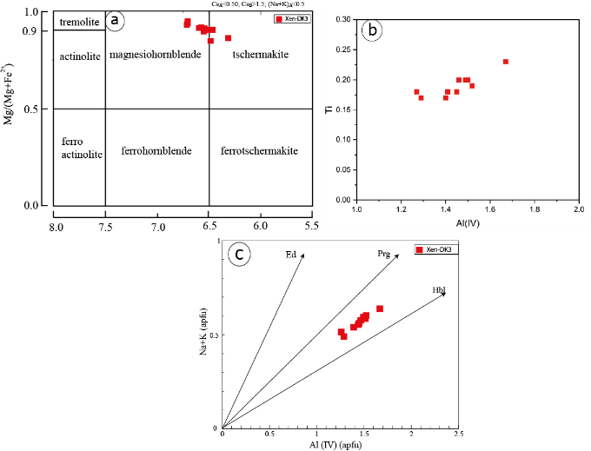

Figure 7. a) Major element data for amphiboles from diorite enclaves plotted on the Mg/(Mg+Fe²⁺) vs. Si classification diagram [22].b) Al (Al^{IV}) plotted vs. Ti for amphibole from the diorite enclaves[23]. C) Exchange vectors diagram of Edenite-Pargazite and Hornblende based on Al^{IV} amounts vs. (Na+ K), for diorite enclaves [22].

The chemical composition of amphibole is a proxy for the oxygen fugacity the magma from which they crystallized. Oxygen fugacity can be calculated based on models by [24, 25] and according to cationic Fe# ratios. Values between 0 to 0.6 indicate high oxygen fugacity, 0.6 to 0.8 indicates average oxygen fugacity and ratios ~1 indicate low oxygen fugacity. The chemical composition of studied amphibole shows Fe# ratios between 0.28 and 0.33, consistent with high oxygen fugacity conditions. An additional oxygen fugacity model [26] was used, using the equation Log fO2 = -30930/T + 14.98 + 0.142 (P-1)/T. Values ranging between -15 and -13 for diorite enclaves (Table 6) are, once again, consistent with high oxygen fugacity. Furthermore, the occurrence of quartz and sphene together with amphibole is indicative of high oxygen fugacity conditions [26] and thus consistent with our calculations.

6. Mineral Chemistry of Pyroxene

This section focuses on clinopyroxene, observed as xenocrysts in DK3-type diorite dykes and a metasomatic phase in Sungun skarn units. The general formula for Pyroxene group minerals is M1M2T2O6; the M2 site can be occupied by Ca (Calcic Pyroxenes), Na (sodic pyroxenes), Mn, Fe²⁺ and/or Mg; the M1 position can be occupied by Al, Cr, Fe³⁺, Ti, Fe²⁺ and/or Mg; and the T position is occupied by Si and Al (e.g., [19]). Structural formulae are calculated based on six oxygen atoms and four cations. The results of the analysis are shown in Table 4. The amount of Al in T site is so elevated that it can compensate the Si4+ shortage in the T position. The amounts of Al^{IV} and Si at the T site are 0.14-0.27 and 1.73-1.86, respectively. The M1 position frequently has amounts of Mg (0.62-0.80), Fe3+ (0.05-0.22), Al^{IV} (0.10-0.16) and Ti (0.03-0.05) and the M2 position is occupied by Ca (0.44-0.51) although others contain Fe²⁺ (0.20-.033), Mg (0.05-0.18), Na (0.08-0.13), K (0.02-0.05) and Mn (0.01). The observed differences in Fe³⁺ can be described by various modes of oxidation during magmatic conditions. The average composition is as follows:

(Ca_{0.46}7Fe²⁺_{0.24}Mg_{0.136}Na _{0.108}K _{0.033}Mn _{0.01}) (Mg _{0.675}Fe³⁺_{0.168}Al^{VI} _{0.117}Ti _{0.041}) (Si _{1.774}Al^{IV} _{0.225})₂O₆

Al and Ti are tchermak replacement, meaning replacement of Mg and Fe by Ti at the M2 site and replacement of Al by Si at the T site. Accordingly, Al/Ti ratios are greater than 10 (Fig. 8a) and the observed correlation between Fe³⁺ and Al (Fig. 8b) indicates that the calcium tchermak component is the most important part of the clinopyroxene’s composition. Furthermore, a diagram of Ti-Al^{IV} shows positive correlation that indicates a linked increase between the two elements (Fig. 8c). In contrast, samples below the 1:2 line indicate that Al is located in a tetrahedral position to offset other substitutions. The Ti-Mg diagram shows a negative correlation and justifies increases of Ti through replacement of Mg (Fig. 8d).

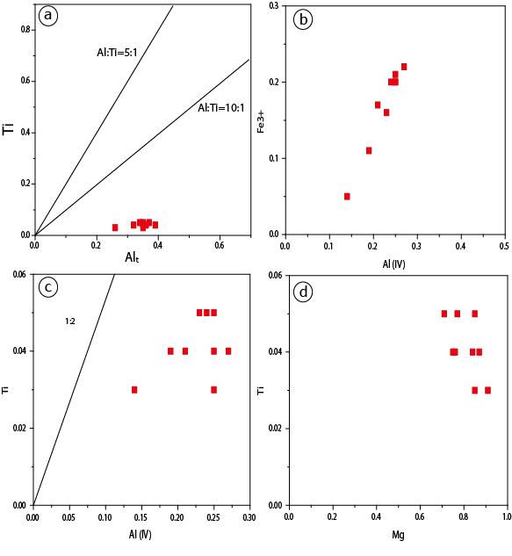

Figure 8. a) Pyroxene xenolith compositions a) Ti vs. Al diagram, in which most samples are located in the Al/Ti zone > 10, b) Fe³⁺ vs. Al ^{IV} diagram where a strong linear correlation between these two cations are observed. c) Ti vs. Al ^{IV} diagram, showing a broad positive correlation between the two, d) Ti vs. Mg diagram showing a negative correlation, revealing the increase of Ti at the expense of Mg.

Table 4. EPMA analysis results of pyroxene of diorite dyke and Sungun skarn [27] (chemical composition of pyroxenes and structural formula based on 6 oxygen atoms)
Sample |  |  |  |  | Sungun |  |  |  |  |  |  |  |  |  | DK3
point | 1 | 2 | 3 | 4 | 5 | 6 | 7 | 8 | 9 | 10 | 2 | 3 | 4 | 5 | 6 | 7 | 8 | 9 | 10
SiO2 | 51.15 | 51.66 | 51.53 | 52.31 | 51.89 | 52.17 | 51.35 | 51.03 | 51.55 | 51.64 | 47.99 | 46.68 | 46.55 | 49.96 | 47.41 | 48.38 | 47.28 | 47.52 | 46.32
TiO2 | 0.07 | 0.03 | 0.13 | 0.08 | 0.07 | 0.02 | 0.08 | 0.02 | 0.12 | 0.08 | 1.25 | 1.62 | 1.68 | 1.14 | 1.22 | 1.27 | 1.57 | 1.68 | 1.31
Al2O3 | 0.57 | 0.59 | 0.63 | 0.28 | 0.14 | 0.13 | 0.27 | 0.47 | 0.64 | 0.27 | 7.84 | 8.31 | 7.9 | 5.9 | 8.03 | 7.3 | 8.14 | 7.78 | 8.85
Cr2O3 | 0 | 0 | 0 | 0 | 0 | 0 | 0 | 0 | 0 | 0 | 0 | 0 | 0 | 0 | 0 | 0 | 0 | 0 | 0
FeO | 14.31 | 12.93 | 14.39 | 13.44 | 14.24 | 13.82 | 14.93 | 13.67 | 14.39 | 14.63 | 13.53 | 14.06 | 12.95 | 12.1 | 13.38 | 12.65 | 13.16 | 12.84 | 13.77
MnO | 0.06 | 0.26 | 0.08 | 0.37 | 0.13 | 0.06 | 0.17 | 0.16 | 0.09 | 0.26 | 0.3 | 0.36 | 0.35 | 0.47 | 0.44 | 0.37 | 0.37 | 0.38 | 0.34
MgO | 9.08 | 10.24 | 9.24 | 10.74 | 9.26 | 9.68 | 8.69 | 9.44 | 9.24 | 8.96 | 13.36 | 12.72 | 13.65 | 16.19 | 15.27 | 15.73 | 15.14 | 15.28 | 13.51
CaO | 23.61 | 23.59 | 23.54 | 22.66 | 23.77 | 23.63 | 23.57 | 23.28 | 23.54 | 23.71 | 11.81 | 11.98 | 12.58 | 11.23 | 11.26 | 11.31 | 11.21 | 11.6 | 12.12
Na2O | 0.98 | 0.61 | 0.57 | 0.54 | 0.44 | 0.48 | 0.58 | 0.08 | 0.52 | 0.33 | 1.41 | 1.76 | 1.56 | 1.14 | 1.65 | 1.59 | 1.66 | 1.4 | 1.56
K2O | 0 | 0 | 0 | 0 | 0 | 0 | 0.04 | 0.02 | 0 | 0 | 0.86 | 1.01 | 0.84 | 0.39 | 0.57 | 0.5 | 0.64 | 0.59 | 0.94
Total | 99.83 | 99.91 | 100.11 | 100.42 | 99.94 | 99.99 | 99.68 | 98.17 | 100.09 | 99.88 | 98.35 | 98.5 | 98.06 | 98.52 | 99.23 | 99.1 | 99.17 | 99.07 | 98.72
Si (T) | 1.96 | 1.97 | 1.97 | 1.98 | 1.99 | 1.99 | 1.98 | 1.99 | 1.97 | 1.99 | 1.81 | 1.76 | 1.75 | 1.86 | 1.75 | 1.79 | 1.75 | 1.77 | 1.73
Al (T) | 0.03 | 0.03 | 0.03 | 0.01 | 0.01 | 0.01 | 0.01 | 0.01 | 0.03 | 0.01 | 0.19 | 0.24 | 0.25 | 0.14 | 0.25 | 0.21 | 0.25 | 0.23 | 0.27
Fe3+ (T) | 0.02 | 0.01 | 0 | 0.01 | 0 | 0 | 0.01 | 0 | 0 | 0 | 0 | 0 | 0 | 0 | 0 | 0 | 0 | 0 | 0
Total (T) | 2 | 2 | 2 | 2 | 2 | 2 | 2 | 2 | 2 | 2 | 2 | 2 | 2 | 2 | 2 | 2 | 2 | 2 | 2
Al (M1) | 0 | 0 | 0 | 0 | 0 | 0 | 0 | 0.01 | 0 | 0 | 0.16 | 0.13 | 0.1 | 0.12 | 0.1 | 0.11 | 0.11 | 0.11 | 0.12
Fe3+ (M1) | 0.11 | 0.08 | 0.06 | 0.05 | 0.04 | 0.04 | 0.06 | 0 | 0.06 | 0.03 | 0.11 | 0.2 | 0.2 | 0.05 | 0.21 | 0.17 | 0.2 | 0.16 | 0.22
Ti (M1) | 0 | 0 | 0 | 0 | 0 | 0 | 0 | 0 | 0 | 0 | 0.04 | 0.05 | 0.05 | 0.03 | 0.03 | 0.04 | 0.04 | 0.05 | 0.04
Cr (M1) | 0 | 0 | 0 | 0 | 0 | 0 | 0 | 0 | 0 | 0 | 0 | 0 | 0 | 0 | 0 | 0 | 0 | 0 | 0
Mg (M1) | 0.52 | 0.58 | 0.53 | 0.61 | 0.53 | 0.55 | 0.5 | 0.55 | 0.53 | 0.51 | 0.7 | 0.63 | 0.65 | 0.8 | 0.65 | 0.69 | 0.65 | 0.69 | 0.62
Fe2+ (M1) | 0.33 | 0.33 | 0.4 | 0.34 | 0.42 | 0.4 | 0.41 | 0.44 | 0.4 | 0.44 | 0 | 0 | 0 | 0 | 0 | 0 | 0 | 0 | 0
Mn (M1) | 0 | 0.01 | 0 | 0 | 0 | 0 | 0.01 | 0 | 0 | 0.01 | 0 | 0 | 0 | 0 | 0 | 0 | 0 | 0 | 0
Total (M1) | 0.96 | 0.99 | 0.99 | 1 | 0.99 | 1 | 0.98 | 1 | 1 | 1 | 1 | 1 | 1 | 1 | 1 | 1 | 1 | 1 | 1
Mg (M2) | 0 | 0 | 0 | 0 | 0 | 0 | 0 | 0 | 0 | 0 | 0.05 | 0.08 | 0.12 | 0.11 | 0.2 | 0.18 | 0.19 | 0.16 | 0.14
Fe2+ (M2) | 0 | 0 | 0 | 0.03 | 0 | 0 | 0 | 0.01 | 0 | 0 | 0.32 | 0.24 | 0.21 | 0.33 | 0.2 | 0.22 | 0.21 | 0.24 | 0.21
Mn (M2) | 0 | 0 | 0 | 0.01 | 0 | 0 | 0 | 0.01 | 0 | 0 | 0.01 | 0.01 | 0.01 | 0.01 | 0.01 | 0.01 | 0.01 | 0.01 | 0.01
Ca (M2) | 0.97 | 0.96 | 0.96 | 0.92 | 0.98 | 0.97 | 0.97 | 0.97 | 0.97 | 0.98 | 0.48 | 0.48 | 0.51 | 0.45 | 0.45 | 0.45 | 0.44 | 0.46 | 0.49
Na (M2) | 0.07 | 0.05 | 0.04 | 0.04 | 0.03 | 0.04 | 0.04 | 0.01 | 0.04 | 0.02 | 0.1 | 0.13 | 0.11 | 0.08 | 0.12 | 0.11 | 0.12 | 0.1 | 0.11
K (M2) | 0 | 0 | 0 | 0 | 0 | 0 | 0 | 0 | 0 | 0 | 0.04 | 0.05 | 0.04 | 0.02 | 0.03 | 0.02 | 0.03 | 0.03 | 0.04
Total (M2) | 1.04 | 1.01 | 1.01 | 1 | 1.01 | 1 | 1.02 | 1 | 1 | 1 | 1 | 1 | 1 | 1 | 1 | 1 | 1 | 1 | 1
Wo | 53.38 | 51.46 | 51.1 | 48.59 | 50.8 | 50.36 | 51.62 | 49.34 | 50.9 | 50.6 | 30.83 | 33.53 | 34.2 | 26.73 | 30 | 29.1 | 29.9 | 29.88 | 33.57
En | 28.56 | 31.08 | 27.91 | 32.04 | 27.54 | 28.7 | 26.48 | 27.84 | 27.8 | 26.61 | 48.53 | 49.53 | 51.63 | 53.62 | 56.61 | 56.31 | 56.19 | 54.77 | 52.06
Fs | 18.06 | 17.46 | 21 | 19.37 | 21.66 | 20.94 | 21.91 | 22.82 | 21.31 | 22.79 | 20.64 | 16.94 | 14.17 | 19.64 | 13.38 | 14.59 | 13.92 | 15.34 | 14.37
Q | 1.81 | 1.87 | 1.89 | 1.89 | 1.92 | 1.92 | 1.89 | 1.97 | 1.9 | 1.93 | 1.55 | 1.44 | 1.48 | 1.68 | 1.49 | 1.54 | 1.49 | 1.54 | 1.45
J | 0.15 | 0.09 | 0.08 | 0.08 | 0.07 | 0.07 | 0.09 | 0.01 | 0.08 | 0.05 | 0.21 | 0.26 | 0.23 | 0.17 | 0.24 | 0.23 | 0.24 | 0.2 | 0.23

Diagrams of Ti+Cr+Na vs. Al are used to determine whether clinopyroxene is igneous or metamorphic in nature. All analyzed xenocrysts have compositions consistent with an igneous origin (Fig. 9a). The classification based on the Q-J diagram [28] indicates that xenoliths are in the group of Ca-Mg-Fe clinopyroxene (Fig. 9b). Based on the En-Wo-Fs ternary diagram, clinopyroxene xenocrysts are augite whereas pyroxene from the Sungun skarn are diopside [27] (Fig. 9c). In the alternate classification scheme by [29], the Ti-Na-Al^{IV} clinopyroxene ternary diagram shows that clinopyroxene plots in the CATS range, consistent with clinopyroxene-tchermak calcium compositions (Fig. 9d).

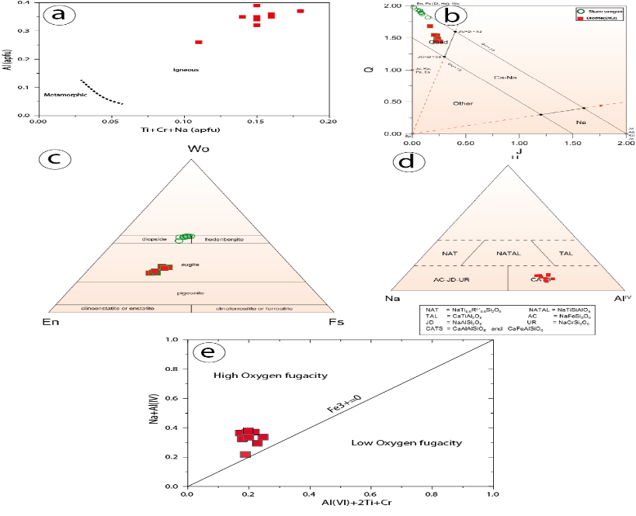

Figure 9. a) Al diagram vs. Ti-Na- Cr , to distinguish igneous from metamorphic pyroxene; all clinopyroxene xenocrysts are located in igneous field [30]. b) The Q-J clinopyroxene classification diagram [31].c) Wo-En-Fs ternary diagrams of pyroxene xenocrysts [32]. d) Clinopyroxene ternary diagram of Ti-Na- Al IV, studied samples are located exclusively in the CATS field, based on this diagram .e) An estimation of oxygen fugacity from pyroxene xenocryst compositions in diorite dykes [32].

Oxygen fugacity has a special effect on changes of the liquidus temperature and magma composition [33] and is also an effective factor for controlling magmatic processes and the sequence of crystallization [34–37]. To determine the degree of oxygen fugacity in the primary magma by using chemistry combination of clinopyroxene, the total amount of Al^{IV}+2Ti+Cr has been used against Na+Al^{IV} [33] (Fig. 9e). Fe³⁺ in the octahedral position replaces elements such as Cr and Al^{IV}. Therefore, the clinopyroxene amount of Fe³⁺ in pyroxenes depends strongly on the amount of Al^{IV}: whenever more aluminum enters into the tetrahedral position, the possibility for Fe³⁺ to enter M sites will increase. In the diagram (Fig. 9e), the Fe³⁺=0 line is a proxy for oxygen fugacity; data points that plot above the line indicate high fugacities, and distance from this line indicates greater fugacity values. Fe³⁺ content of xenocrysts from Sungun are thus consistent with high oxygen fugacity during magmatic clinopyroxene crystallization.

7. Magmatic Series and Tectonic Environment

7.1) Magma series from amphibole composition

Bivariate diagrams of Al₂O₃ vs. TiO₂ [38] are used to determine the source and nature of the magma in diorite enclaves of the region from chemical composition of amphibole. Studied samples are largely located within sub-alkaline field, with only a few transitional samples plotting within the sub-alkaline & alkaline field (Fig. 10a and b). These data are consistent with previously reported whole rock geochemistry showing the calc-alkalic to alkalic nature of the Sungun magmas [18].

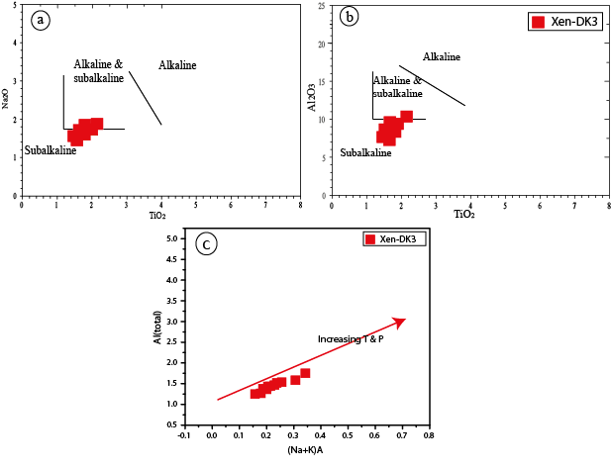

Figure 10. (a) Al₂O₃ vs. TiO₂ and (b) Na₂O vs. TiO₂ diagram for amphibole[38]. The dioritic enclave samples are dominantly located in subalkaline fields. c) (Na+K) A vs. (Al) total in amphiboles and diorite enclaves.

7.2) Temperature estimates from chlorite

Temperatures estimated from Sungun chlorite compositions are provided in Table 5 for several chlorite geothermometers [39–43]. The estimates obtained from models by [43] and [39] are most applicable to diagenetic, hydrothermal and metamorphic environments because the tetrahedral structure of aluminum is independent from bulk rock chemistry:

T= -61.92+321.98AlIV (1).

[43] categorized geo-thermometers for chlorite formed in hydrothermal environments saturated in aluminum (i.e., in the presence of other aluminum minerals). They corrected the tetrahedral structure of aluminum and rewrote equation (1):

AlcIV=AlIV+0.7Fe/(Fe+Mg)T=106AlcIV+18 (2)

The correction to equation (2) proposed by [44], which is applicable to similar temperature ranges, is only applicable for low Fe chlorite (Fe > 0.6). The [43] model is thus the most appropriate for this study.

[45] studied combinations of chlorite in the meta-volcanic rocks of the Barton Greenstone belt, which includes basalt and dacite, and have proposed a chlorite geo-thermometer equation with a correction of 0.31 on the Fe/(Fe+Mg) ratio:

TX97-Al^{IV} (°C) = 106.99×((Al^{IV}O28) + 1.33*(0.31- Fe/(Fe+Mg))) – 61.92if Fe⁄((Fe+Mg))< 0.31 (3)

TX97-Al^{IV} (°C) = 106.99×((Al^{IV}O28) + 1.33*(0.31- Fe/(Fe+Mg))) – 61.92if Fe⁄((Fe+Mg))> 0.31 (4)

Several experimental correction factors have been used in chlorite geo-thermometers to reduce the effect of bulk rock composition and contamination from other aluminum phases (e.g.,[39,46]). For most experimental chlorite geo-thermometers, the amount of Al^{IV} is estimated by using the 28-oxygen normalization method; however, in other models, a normalization to 14-oxygen is preferred. Nevertheless, the application of both chlorite normalizations (i.e., differences in sites of octahedral occupation) to the same geo-thermometer generates only minor variations in modeled temperatures.

Results from the two favored chlorite geothermometers ([43]; [39] Table 5) indicate temperatures ranging between 263°C and 311°C for DK1b diorite enclaves, and between 230°C and 258°C for DK3 microdiorite enclaves.

Table 5. Results of the thermometry calculations of chlorites in the diorite and micro diorite enclaves
Sample |  | Cathelineau andNieva(1985) | KranidiotisandMacLean(1987) | Cathelineau (1988) | Kavalierisetal.(1990) | Jowett(1991) | Hiller andVelde(1991) | De Caritat etal.(1993) | De Caritat etal.(1993) | Zang andFyfe(1995) | Xie etal.(1997) | El-Sharkawy(2000)
b1 |  | 271 | 319 | 328 | 241 | 337 | 280 | 305 | 335 | 251 | 206 | 231
b2 |  | 255 | 303 | 305 | 209 | 313 | 244 | 285 | 281 | 237 | 188 | 217
b3 |  | 258 | 306 | 309 | 214 | 317 | 249 | 289 | 289 | 238 | 188 | 218
b4 |  | 260 | 309 | 312 | 219 | 321 | 255 | 298 | 298 | 240 | 188 | 220
b5 | DK1b | 260 | 309 | 313 | 219 | 321 | 255 | 291 | 299 | 240 | 189 | 220
b6 |  | 265 | 313 | 320 | 229 | 328 | 267 | 292 | 316 | 246 | 201 | 226
b7 |  | 272 | 320 | 330 | 244 | 338 | 282 | 306 | 339 | 253 | 211 | 233
b8 |  | 244 | 291 | 289 | 189 | 297 | 218 | 282 | 527 | 227 | 177 | 207
b9 |  | 268 | 316 | 325 | 237 | 333 | 274 | 296 | 328 | 250 | 206 | 229
b10 |  | 273 | 322 | 332 | 248 | 341 | 286 | 295 | 345 | 253 | 209 | 233
Average |  | 263 | 311 | 316 | 225 | 325 | 261 | 294 | 336 | 244 | 196 | 223
Max |  | 273 | 322 | 332 | 248 | 341 | 286 | 306 | 527 | 253 | 211 | 233
Min |  | 244 | 291 | 289 | 189 | 297 | 218 | 282 | 281 | 227 | 177 | 207
k1 |  | 229 | 257 | 266 | 165 | 266 | 183 | 248 | 474 | 237 | 267 | 219
k2 |  | 232 | 259 | 270 | 169 | 270 | 189 | 252 | 483 | 239 | 270 | 221
k3 |  | 228 | 255 | 264 | 163 | 264 | 180 | 246 | 470 | 236 | 267 | 218
k4 |  | 233 | 260 | 271 | 170 | 271 | 191 | 258 | 485 | 240 | 271 | 222
k5 |  | 238 | 266 | 279 | 178 | 279 | 203 | 267 | 505 | 245 | 277 | 227
k6 |  | 229 | 256 | 265 | 164 | 265 | 182 | 256 | 473 | 236 | 266 | 219
k7 |  | 226 | 253 | 260 | 160 | 260 | 174 | 257 | 461 | 233 | 262 | 215
k8 | DK3 | 230 | 257 | 267 | 166 | 267 | 185 | 264 | 477 | 238 | 270 | 220
k9 |  | 235 | 263 | 274 | 173 | 274 | 195 | 266 | 493 | 241 | 272 | 224
k10 |  | 225 | 252 | 259 | 158 | 258 | 172 | 252 | 457 | 232 | 260 | 214
k11 |  | 231 | 258 | 268 | 167 | 268 | 187 | 261 | 480 | 238 | 269 | 221
k12 |  | 222 | 249 | 255 | 155 | 255 | 166 | 249 | 448 | 231 | 261 | 213
k13 |  | 222 | 248 | 254 | 154 | 254 | 165 | 258 | 447 | 230 | 260 | 212
k14 |  | 240 | 267 | 282 | 182 | 282 | 208 | 275 | 511 | 247 | 282 | 229
k15 |  | 237 | 265 | 277 | 176 | 277 | 200 | 264 | 500 | 244 | 276 | 226
Average |  | 230 | 258 | 267 | 167 | 267 | 185 | 258 | 478 | 238 | 269 | 220
Max |  | 240 | 267 | 282 | 182 | 282 | 208 | 275 | 511 | 247 | 282 | 229
Min |  | 222 | 248 | 254 | 154 | 254 | 165 | 246 | 447 | 230 | 260 | 212

7.3) Pressure and temperature estimates from amphibole

Experimental results have shown that the composition of amphibole, depends on pressure, temperature, oxygen partial pressure (fugacity), total composition of the rock and coeval formation of other mineral phases [47,48]. In this study, to estimate of crystallization pressure of selected amphiboles, four conventional methods have been used based on Al in hornblende [48–51]; results are presented in Table 6. Pressure estimates obtained from these models range between 3.0 to 5.3 kilobars (approximate depths of 9 to 16 kilometers), and standard deviations generally indicate that the degree of variation for each of these methods is negligible.

In all of the above models, the pressure of formation is determined solely from the total amount of Al, and other parameters such as temperature are not considered. Many formulas have been proposed for calculating pressure. The model by [52] is appropriate for conditions consistent with convergent margins:

P = -3.01+4.76(Al total) (5)

The above formula allows the determination of peak pressures of crystallization [51]. High amounts of magnetite and ilmenite indicate high oxygen fugacity, and the amphiboles that crystallize in such conditions tend to show more reliable results for geothermobarometry [47,48]. Plagioclase and hornblende grains that are adjacent and equilibrated with each other are useful for thermometry, and the usage of this pair of minerals in igneous rocks is independent to the presence or absence of quartz.

The calculation of the temperature in the formula which is presented by [53] (Table 6), shows that the temperature range for the diorite enclaves are between 714 to 731°C. This temperature indicates mineral replacement in diorite enclaves occurs within Dk3 diorite dykes during late magmatic stages. Diagrams of the main elements of amphibole compared to (Na+K)A and total aluminum Al(total), which respectively show the temperature [54] and pressure[48] conditions of amphibole crystallization, provide insight on the pressure and temperature conditions at the time of crystallization. Experimental studies have shown that atomic amounts of Al(total) and (Na+K)A depend on the temperature of the system and often exhibit high positive correlation with each other [55,56]. Analysis of these diagrams shows a positive correlation between amounts of Al(total) and (Na+K)A consistent with such temperature increases for the dioritic enclaves (Fig. 10c). According to these diagrams, amounts of Mg and Si decrease with increasing Al total. Decreases in Si are accompanied by increases in Ti (Fig. 11), indicating substitution associated with increasing pressure. With respect to (Na+K)A, negative correlations with Si and Mg are consistent with increasing temperatures (Fig. 11). Mg decreases are likely related to replacement by Fe.

Table 6. Results of geothermobarometery and oxygen fugacity from amphibole in the diorite enclaves (DK3)
Sample | P1(kbar) | P2(kbar) | P3(kbar) | P4(kbar) | T1(oC) | T2(oC) | T3(oC) | T4(oC) | fO2
X1 | 4.815 | 5.034 | 3.886 | 5.256 | 754 | 750 | 768 | 747 | -13.63
X2 | 3.559 | 3.627 | 2.83 | 4.068 | 732 | 731 | 743 | 725 | -14.67
X3 | 3.452 | 3.506 | 2.74 | 3.966 | 732 | 732 | 743 | 725 | -14.75
X4 | 2.572 | 2.519 | 1.999 | 3.133 | 708 | 709 | 716 | 700 | -15.51
X5 | 2.427 | 2.357 | 1.878 | 2.997 | 715 | 716 | 723 | 707 | -15.64
X6 | 3.851 | 3.953 | 3.075 | 4.344 | 739 | 737 | 750 | 732 | -14.42
X7 | 3.562 | 3.629 | 2.832 | 4.07 | 727 | 727 | 738 | 720 | -14.67
X8 | 3.106 | 3.118 | 2.448 | 3.638 | 720 | 720 | 729 | 712 | -15.05
X9 | 4.007 | 4.128 | 3.206 | 4.491 | 729 | 727 | 741 | 722 | -14.28
X10 | 3.279 | 3.312 | 2.594 | 3.803 | 721 | 721 | 731 | 714 | -14.91
Average | 3.463 | 3.5183 | 2.7488 | 3.9766 | 727.7 | 727 | 738.2 | 720.4 | -14.753
Max | 4.815 | 5.034 | 3.886 | 5.256 | 754 | 750 | 768 | 747 | -13.63
Min | 2.427 | 2.357 | 1.878 | 2.997 | 708 | 709 | 716 | 700 | -15.64
P1=-3.92 + 5.03* Al(total) [48]; P2=-4.76 + 5.64* Al(total) [49]; P3=-3.46 + 4.23* Al(total) [50]; p4=-3.01 + 4.76* Al(total) [51].

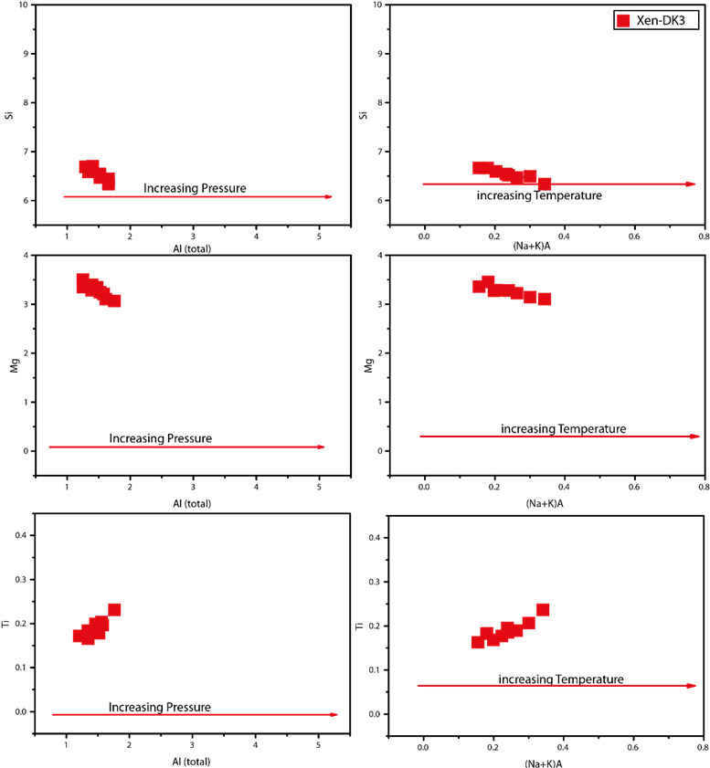

Figure 11. The Al(total) vs. Ti, Mg, Si and (Na+K)A diagram vs. the Ti, Mg, Si for the study of chemical composition changes of dioritic enclaves. Associated inferred pressure and temprature changes are indicated with red arrows.

7.4) Pressure and temperature estimates from pyroxene

The Winpyrox application by [57] was used for the thermobarometric analysis of pyroxene xenocrysts. The chemical composition of pyroxenes is an important index for measuring temperature and pressure of igneous rocks. Experiential research has shown that the amount of AlIV in clinopyroxene depends on pressure[58]. [59] proposed a model for the estimation of temperature and pressure of clinopyroxene formation based on XPT and YPT indexes, which can be calculated with the following equations:

XpT= 0.446 SiO2+ 0.187 TiO20.404 Al2O3+ .0.346 FeO(tot) 0.052 MnO + 0.309 MgO + .0.431 CaO 0.446 Na2O. (6)

YpT= 0.369 SiO2+ 0.535 TiO20.317 Al2O3+.0.323 FeO(tot) + 0.235 MnO 0.516 MgO-0.167 CaO 0.153 Na2O (7)

Using these indexes, we estimate pressures ranging between 11 to 15 kbar for the Sungun clinopyroxene xenocrysts (Fig. 12a), and a temperature of formation ranging between 1250°C and 1300°C (Fig. 12b). These are consistent with results from other geothermometers and geobarometers provided in Tables 7 and 8.

Table 7. Results of geobarometry calculations for clinopyroxene xenocrysts
Rock  Type | Sample  No. | Nimis  1995 | Nimis and  Ulmer  1998 Basic  anhydrous | Nimis  1999  (Th) | Putrika  2008
Error | Kbar | ± 1.75 | ± 1.70 | ± 1.00 | ± 2.80
 | 1 | 13.72 | 14.66 | 16.01 | 17.87
 | 2 | 14.82 | 15.73 | 22.86 | 19.07
 | 3 | 13.64 | 14.41 | 24.53 | 19.49
 | 4 | 12.22 | 12.89 | 24.09 | 18.13
DK3 | 5 | 11.56 | 12.58 | 24.48 | 16.38
 | 6 | 13.21 | 14.11 | 25.20 | 18.25
 | 7 | 12.90 | 13.84 | 25.36 | 18.24
 | 8 | 13.44 | 14.35 | 25.66 | 18.16
 | 9 | 12.40 | 13.25 | 25.11 | 16.96
 | 10 | 13.76 | 14.54 | 25.38 | 18.09
 | Max | 14.82 | 15.73 | 25.66 | 19.49
 | Min | 11.56 | 12.58 | 16.01 | 16.38
 | Average | 13.17 | 14.06 | 23.36 | 18.04

Table 8. Results of the geothermometry calculations for clinopyroxene xenocrysts
Rock  Type | Sample  No. | Bertrand and  Mercier  (1985/1986) | Nimis  and Taylor  -2000 | Putrika 2008 | Dal Negro  -1982 | Molin and  Zanazzi  -1991
Error | ºC | ± 50 | ± 30 | ± 30 | ± 30 | ± 30
 | 1 | 1431.00 | 1104.00 | 1172.00 | 816.00 | 894.00
 | 2 | 1425.00 | 1068.00 | 1171.00 | 854.00 | 901.00
 | 3 | 1427.00 | 1054.00 | 1178.00 | 867.00 | 903.00
 | 4 | 1419.00 | 1069.00 | 1185.00 | 863.00 | 902.00
DK3 | 5 | 1446.00 | 1170.00 | 1176.00 | 716.00 | 882.00
 | 6 | 1446.00 | 1125.00 | 1204.00 | 833.00 | 896.00
 | 7 | 1446.00 | 1136.00 | 1197.00 | 809.00 | 892.00
 | 8 | 1446.00 | 1113.00 | 1194.00 | 831.00 | 896.00
 | 9 | 1440.00 | 1119.00 | 1185.00 | 812.00 | 893.00
 | 10 | 1427.00 | 1083.00 | 1196.00 | 865.00 | 903.00
 | Max | 1446.00 | 1170.00 | 1204.00 | 867.00 | 903.00
 | Min | 1419.00 | 1054.00 | 1171.00 | 716.00 | 882.00
 | Average | 1434.83 | 1105.42 | 1186.08 | 820.75 | 895.58

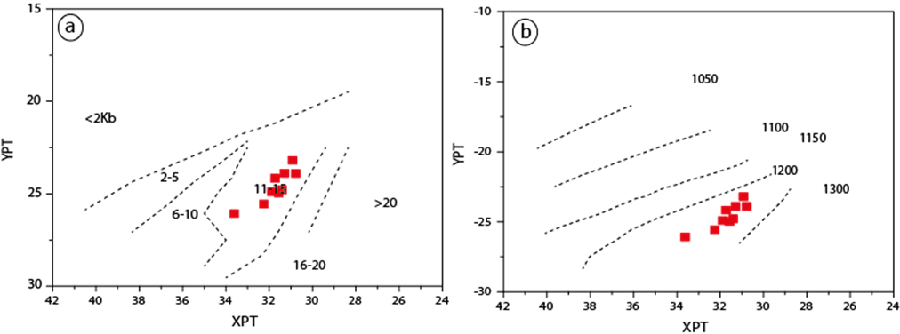

Figure 12. Estimations of a) crystallization pressure and b) crystallization temperature of clinopyroxene xenocrysts

8. Discussion and Conclusion

Previous studies on samples of the Sungun dykes and the Sungun porphyry show that they have bulk rock compositions more consistent with the post-collisional magmatic arc domain than magmas from continental active margins [4,11]. Similarities between REE patterns of the dykes and the porphyry suggest that their magmas share a common origin. However, the dykes are compositionally slightly more mafic and younger in age. All samples, with the exception of the micro-diorite, plot in similar 87Sr/86Sr versus 143Nd/144Nd space, showing ratios consistent with a mantle source. The isotope ratio of these rocks originated mainly from the melt extraction from a mantle source within a closed system. Thermobarometry of the dykes indicates that their magmas formed from the extraction of an intermediate magma and another magma of mixed crustal-mantle affinity. At a maximum pressure of 19 kbar, gravitational separation of the magmas within a lower-crustal magmatic chamber gave rise to the dioritic magma. This magma then rose and settled into another chamber at a maximum of 6 kbar (~18 km), where it fractionated and gravitationally separated. These magmas rose again in sequence, thereby creating the more felsic and earlier Sungun porphyry and the subsequent more mafic Sungun dykes [16,18].

Dioritic dykes in eastern skarn part of Sungun copper deposit contain abundant clinopyroxene xenocrysts. Although previous workers had proposed that these were inherited from the skarn (add references on skarn origin), our work shows that the xenoliths are augitic, contrasting with the diopsidic composition of clinopyroxene from the skarn. We propose that the xenocrysts are magmatic in origin. Substitution mechanisms of studied clinopyroxenes depend on variations in physical and chemical conditions and the distribution of Al and Ti minerals in the source magma. Pressures of formation of clinopyroxene xenocrysts in diorite dykes are estimated between 11 to 15 kilobars, and temperatures of 1200°C, consistent with early stage, lower crustal (maximum 19 kbar) magmatic activities deduced from dyke thermobarometry [11]. High Fe³⁺ contents are consistent with high oxygen fugacities during early magmatic conditions.

Results stemming from the mineral analyses of enclaves described in this work constrain the later-stage cooling and retrograde alteration processes that occurred in Sungun magmas. Amphibole crystallization occurred at fairly well constrained temperatures (714-731°C), at pressures ranging between 3.0 and 5.3 kbar (9- 16 km), as later dioritic magmas rose upwards in the crust. Amphiboles within the enclaves consist of calcic amphibole and a sub-group of magnesio-hornblende; such compositions, along with high cationic Fe, reflect high oxygen fugacity at the time of crystallization and are thus consistent with a supra-subduction zone (magmatic arc) environment. As the system cooled, later hydrothermal alteration and chloritization occurred at much lower temperatures: the retrograde formation of chlorite in microdiorite and diorite occurred at approximately 272°C and 257°C, respectively.

Recent petrologic studies of intrusive rocks of the Sungun Cu-Mo porphyry deposit show that the main stock of the intrusion and its and peripheral dykes consist of, in order of abundance, quartz monzonite, quartz diorite, gabbro diorite, microdiorite, dacite and lamprophyre [11]. Generally, enclaves observed in late dykes consist of quartz diorite, diorite, hornfels and microdiorite. These findings have implications for our understanding of the genesis of the intrusion and its deposit. Indeed, previous work has documented that the stock consists of an early quartz monzonitic magma pulse, followed by a dioritic/granodioritic pulse [13]. In contrast, our results suggest that the intrusion consists of multiple pulses expressed as several sequential episodes of magma intrusion that are more lithologically diverse than previously described. Furthermore, the temperature of chloritization documented here is consistent but at the lower temperature range of previous estimates for propylitic hydrothermal alteration at Sungun [8].

Acknowledgements

Particular thanks go to Dr. Ahmadian (Payame Noor University) for precise EPMA analyses. Funding for this study was provided by the University of Tabriz.

References
1. Sillitoe, R.H. Porphyry copper systems. Economic geology 2010, 105, 3–41.
2. Richards, J.P. Postsubduction porphyry Cu-Au and epithermal Au deposits: Products of remelting of subduction-modified lithosphere. Geology 2009, 37, 247–250.
3. Logan, J.M.; Mihalynuk, M.G. Tectonic controls on early Mesozoic paired alkaline porphyry deposit belts (Cu-Au±Ag-Pt-Pd-Mo) within the Canadian Cordillera. Economic Geology 2014, 109, 827–858.
4. Kamali, A.A.; Moayyed, M.; Amel, N.; Hosseinzadeh, M.R.; Mohammadiha, K.; Santos, J.F.; Brenna, M. Post-mineralization, cogenetic magmatism at the sungun cu-mo porphyry deposit (Northwest Iran): Protracted melting and extraction in an arc system. Minerals 2018, 8, doi:10.3390/MIN8120588.
5. Nabavi, M.H. An introduction to the geology of Iran, Geological Survey of Iran 1976.
6. Moayyed, M. Petrologic studies of Tertiary volcano-plutonic belt in Western Alborz-Azerbaijan, with a special focus on Hashtchin area, Iran, Shahid Beheshti, 2001, Vol. Ph.D.
7. Osanloo, M.; Ataei, M. Using 2d lerchs and grossmann algorithm to design final pit limits of sungun copper deposit of Iran. International Journal of Engineering 2000, 13, 81–89.
8. Hezarkhani, A.; Williams-Jones, A.E. Controls of alteration and mineralization in the Sungun porphyry copper deposit, Iran; evidence from fluid inclusions and stable isotopes. Economic Geology 1998, 93, 651–670.
9. Hassanpour, S. Metallogeny and mineralization of copper and gold in Arasbaran zone (Eastern Azerbaijan), PhD Thesis, Shahid Beheshti University, Tehran (in Persian with English abstract), 2010.
10. Jamali, H.; Dilek, Y.; Daliran, F.; Yaghubpur, A.; Mehrabi, B. Metallogeny and tectonic evolution of the Cenozoic Ahar--Arasbaran volcanic belt, northern Iran. International Geology Review 2010, 52, 608–630.
11. Kamali, A.A.A.A.; Moayyed, M.; Amel, N.; Mohammad, F.; Brenna, M.; Saumur, B.M.B.M.B.M.; Santos, J.F.J.F. Mineralogy, mineral chemistry and thermobarometry of post-mineralization dykes of the Sungun Cu–Mo porphyry deposit (Northwest Iran). Open Geosciences 2020, 12, 764–790, doi:10.1515/geo-2020-0009.
12. Kamali, A.; Mohsen, M.; Amel, N.; Hosainzadeh, M. Mineral chemistry and geochemistry of lamprophyric dykes in the Sungun Cu-Mo porphyry deposit (Varzaghan-Northwestern Iran). Iran. J Crystallogr Miner 2017, 25, 123–138.
13. Hezarkhani, A. Petrology of the intrusive rocks within the Sungun porphyry copper deposit, Azerbaijan, Iran. Journal of Asian Earth Sciences 2006, 27, 326–340.
14. Kamali. A, Moayyed. M, Amel. N, H.M. Mineral chemistry and geochemistry of lamprophyric dykes in the Sungun Cu-Mo porphyry deposit (Varzaghan-Northwestern Iran). Journal of Geoscience 2017, 26, 73–90.
15. Aghazadeh, M.; Hou, Z.; Badrzadeh, Z.; Zhou, L. Temporal–spatial distribution and tectonic setting of porphyry copper deposits in Iran: constraints from zircon U–Pb and molybdenite Re–Os geochronology. Ore geology reviews 2015, 70, 385–406.
16. Mehrpartou, M. Contributions to the geology, geochemistry, ore genesis and fluid inclusion investigations on Sungun Cu-Mo porphyry deposit (North-West of Iran). 1993.
17. Mohamadrez, S. Regional tectonic map of Iran; 2000;
18. Kamali, A.A. Petrology and Mineral chemistry of post mineralization dykes of Sungun Cu-Mo porphyry deposit, North of Varzegan, East-Azerbaijan, Iran, University of Tabriz, 2016, Vol. Ph.D.
19. Deer, W.A.; Howie, R.A.; Zussman, J. An introduction to the rock-forming minerals. Second edition; 1992; ISBN 0582300940.
20. MOAZEN, M. CHLORITE-CHLORITOID-GARNET EQUILIBRIA AND GEOTHERMOMETRY IN THE SANANDAJ-SIRJAN ME-TAMORPHIC BELT, SOUTHERN IRAN. 2004.
21. Chabu, M. The geochemistry of phlogopite and chlorite from the Kipushi Zn-Pb-Cu deposit, Shaba, Zaire. The Canadian Mineralogist 1995, 33, 547–558.
22. Leake, B.E.; Woolley, A.R.; Arps, C.E.S.; Birch, W.D.; Gilbert, M.C.; Grice, J.D.; Hawthorne, F.C.; Kato, A.; Kisch, H.J.; Krivovichev, V.G. Report. Nomenclature of amphiboles: report of the subcommittee on amphiboles of the international mineralogical association commission on new minerals and mineral names. Mineralogical magazine 1997, 61, 295–321.
23. Coltorti, M.; Bonadiman, C.; Faccini, B.; Grégoire, M.; O’Reilly, S.Y.; Powell, W. Amphiboles from suprasubduction and intraplate lithospheric mantle. Lithos 2007, 99, 68–84.
24. Anderson, J.L.; Smith, D.R. The effects of temperature and f O2 on the Al-in-hornblende barometer. American mineralogist 1995, 80, 549–559.
25. Spear, F.S. An experimental study of hornblende stability and compositional variability in amphibolite. American Journal of Science 1981, 281, 697–734, doi:10.2475/ajs.281.6.697.
26. Wones, D.R. Significance of the assemblage titanite+ magnetite+ quartz in granitic rocks. American Mineralogist 1989, 74, 744–749.
27. Alavi, G. Study of the skarn deposits around the Sheyvar-Dagh batolith and comparison with the Sungun porphyry skarn. Geology. Tabriz 2014.
28. Morimoto, N. Nomenclature of pyroxenes. Mineralogical Journal 1989, 14, 198–221.
29. Papike, J.J. Amphiboles and pyroxenes: Characterization of other than quadrilateral components estimates of ferric iron from microprobe data. In Proceedings of the Geological Society of America Abstracts with Programs; 1974; Vol. 6, pp. 1053–1054.
30. Berger, J.; Femenias, O.; Mercier, J.C.C.; Demaiffe, D. Ocean-floor hydrothermal metamorphism in the Limousin ophiolites (western French Massif Central): evidence of a rare preserved Variscan oceanic marker. journal of Metamorphic geology 2005, 23, 795–812.
31. Morimoto, N.; Fabries, J.; Ferguson, A.K. Ginzburg, 1. Y., Ross, M., Seifert, F. A., Zussman, J., Aoki, K. y Gottardi, G 1988, 1123–1133.
32. Schweitzer, E.L.; Papike, J.J.; Bence, A.E. Statistical analysis of clinopyroxenes from deep-sea basalts. American Mineralogist 1979, 64, 501–513.
33. France, L.; Ildefonse, B.; Koepke, J.; Bech, F. A new method to estimate the oxidation state of basaltic series from microprobe analyses. Journal of Volcanology and Geothermal Research 2010, 189, 340–346, doi:10.1016/J.JVOLGEORES.2009.11.023.
34. Botcharnikov, R.E.; Koepke, J.; Holtz, F.; McCammon, C.; Wilke, M. The effect of water activity on the oxidation and structural state of Fe in a ferro-basaltic melt. Geochimica et Cosmochimica Acta 2005, 69, 5071–5085.
35. Kilinc, A.; Carmichael, I.S.E.E.; Rivers, M.L.; Sack, R.O. The ferric-ferrous ratio of natural silicate liquids equilibrated in air. Contributions to Mineralogy and Petrology 1983, 83, 136–140, doi:10.1007/BF00373086.
36. Kress, V.C.; Carmichael, I.S.E.E. The compressibility of silicate liquids containing Fe2O3 and the effect of composition, temperature, oxygen fugacity and pressure on their redox states. Contr. Mineral. and Petrol. 1991, 108, 82–92, doi:10.1007/bf00307328.
37. Moretti, R. Polymerisation, basicity, oxidation state and their role in ionic modelling of silicate melts. Annals of Geophysics 2005.
38. Molina, J.F.; Scarrow, J.H.; Montero, P.G.; Bea, F. High-Ti amphibole as a petrogenetic indicator of magma chemistry: evidence for mildly alkalic-hybrid melts during evolution of Variscan basic--ultrabasic magmatism of Central Iberia. Contributions to Mineralogy and Petrology 2009, 158, 69–98.
39. Cathelineau, M.; Nieva, D. A chlorite solid solution geothermometer the Los Azufres (Mexico) geothermal system. Contributions to Mineralogy and Petrology 1985, 91, 235–244.
40. De, C.P.; Hutcheon, I.; Walshe, J.L. Chlorite geothermometry: a review. Clays and Clay Minerals 1993, 41.
41. Jowett, E.C. Fitting iron and magnesium into the hydrothermal chlorite geothermometer. In Proceedings of the GAC/MAC/SEG Joint Annual Meeting, Toronto, May 27-29, 1991, Program with Abstracts 16; 1991.
42. Kavalieris, I.; Walshe, J.L.; Halley, S.; Harrold, B.P. Dome-related gold mineralization in the Pani volcanic complex, North Sulawesi, Indonesia; a study of geologic relations, fluid inclusions, and chlorite compositions. Economic Geology 1990, 85, 1208–1225.
43. Kranidiotis, P.; MacLean, W.H. Systematics of chlorite alteration at the Phelps Dodge massive sulfide deposit, Matagami, Quebec. Economic Geology 1987, 82, 1898–1911.
44. De Caritat, P.; Hutcheon, I.A.N.; Walshe, J.L. Chlorite geothermometry: a review. Clays and clay minerals 1993, 41, 219–239.
45. Xie, X.; Byerly, G.R.; Ferrell Jr, R.E. IIb trioctahedral chlorite from the Barberton greenstone belt: crystal structure and rock composition constraints with implications to geothermometry. Contributions to Mineralogy and Petrology 1997, 126, 275–291.
46. Cathelineau, M. Cation site occupancy in chlorites and illites as function of temperature. Clay minerals 1988, 23, 471–485.
47. Esawi, E.K. AMPH-CLASS: An Excel spreadsheet for the classification and nomenclature of amphiboles based on the 1997 recommendations of the International Mineralogical Association. Computers \& Geosciences 2004, 30, 753–760.
48. Hammarstrom, J.M.; Zen, E. Aluminum in hornblende: an empirical igneous geobarometer. American mineralogist 1986, 71, 1297–1313.
49. Hollister, L.S.; Grissom, G.C.; Peters, E.K.; Stowell, H.H.; Sisson, V.B. Confirmation of the empirical correlation of Al in hornblende with pressure of solidification of calc-alkaline plutons. American Mineralogist 1987, 72, 231–239.
50. Johnson, M.C.; Rutherford, M.J. Experimental calibration of the aluminum-in-hornblende geobarometer with application to Long Valley caldera (California) volcanic rocks. Geology 1989, 17, 837–841.
51. Schmidt, M.W. Amphibole composition in tonalite as a function of pressure: an experimental calibration of the Al-in-hornblende barometer. Contributions to mineralogy and petrology 1992, 110, 304–310.
52. lNonn Spnpn, J.A.; Vyhnal, C.R.; McSween, H.Y.; Speer, J.A. Hornblende chemistry in southern Appalachian granitoids: Implications for aluminum hornblende thermobarometry and magmatic epidote stability Cnnrsropnrn R. Yvuullr* Hl. nnv Y. McSwnrN, Jn. American Mineralogist 1991, 76, 176–188.
53. Blundy, J.D.; Holland, T.J.B. Calcic amphibole equilibria and a new amphibole-plagioclase geothermometer. Contributions to mineralogy and petrology 1990, 104, 208–224.
54. Humphreys, M.C.S.; Edmonds, M.; Christopher, T.; Hards, V. Chlorine variations in the magma of Soufrière Hills Volcano, Montserrat: Insights from Cl in hornblende and melt inclusions. Geochimica et Cosmochimica Acta 2009, 73, 5693–5708.
55. RUTHERFORD, M.J.; DEVINE, J.D. Magmatic conditions and magma ascent as indicated by hornblende phase equilibria and reactions in the 1995--2002 Soufriere Hills magma. Journal of petrology 2003, 44, 1433–1453.
56. Scaillet, B.; Evans, B.W. The 15 June 1991 Eruption of Mount Pinatubo. I. Phase Equilibria and Pre-eruption P-T-fO2-fH2O Conditions of the Dacite Magma. Journal of Petrology 1999, 40, 381–411, doi:10.1093/petroj/40.3.381.
57. Yavuz, F. WinPyrox: A Windows program for pyroxene calculation classification and thermobarometry. American Mineralogist 2013, 98, 1338–1359.
58. Thompson, R.N. Some high-pressure pyroxenes. Mineralogical Magazine 1974, 39, 768–787.
59. Soesoo, A. A multivariate statistical analysis of clinopyroxene composition: Empirical coordinates for the crystallisation PT-estimations. GFF 1997, 119, 55–60.

