Chapter # (assigned by editor, given in the file name)

HUMAN BEING DEVELOPMENT: A HOLISTIC AND COMPLEX EXTENSIVE REVIEW ON THE SOCIAL DIMENSION

Bertrand Dupuy¹, Roger Boileau², & Tegwen Gadais³
¹Department of Physical Education, Cégep de St Hyacinthe (Canada)
²Department of Physical Education, Université Laval (Canada)
³Department of sciences activity, Université du Québec à Montréal (Canada)

ABSTRACT
A previous paper focuses on the research protocol used to conduct a holistic and complex review on the social dimension of the human being. This theoretical chapter focuses on created a model about the constituent elements of social development of human beings evolving into a contemporary democratic society. From a cross-reading of the thoughts of ancient and contemporary authors, a number of structural, conceptual and dynamic elements related to this subject emerged. The linkage and articulation of these elements gave birth to an integrative model reflecting the complexity of the different components of the social dimension of human beings and their development. This chapter, based on Bronfenbrenner's ecological approach, unveils the process of developing this grid as well as the justification of the constituent elements that it comprises. It establishes a first foundation of knowledge synthesis on the social dimension of human beings.

Keywords: Human being, human development, social dimension, Bronfenbrenner, ecological model

Initial Warnings
Current knowledge of the requirements of good development and good functioning of human beings allows for the definition of new guidelines to redirect our education systems towards the implementation of education and training programs that allow every human to better know oneself and to realize optimally their potential. We want to put into perspective the knowledge generated by several authors to synthesize their approaches and draw the guidelines for this new orientation that is necessary and more respectful of human development. This article is a proposal for the basis of work on which the experts of different fields mentioned in the text will be able to continue the reflection and co-build this holistic framework with us. More than ever, we believe in the importance of this exercise to redefine humanism and education that truly places human beings in what they are, and is most fundamental and in the optimal conditions for them to succeed.

1. INTRODUCTION

1.1. The social development of human beings: a neglected and fragmented concept
At present, many school programs promote on paper the development of individuals in all their dimensions (Ministère de l'Éducation du Loisir et du Sport, 2004; Raveaud, 2006), and in particular their social dimension. Social interactions and citizenship seem to be the watchwords in this area. Although courses in civic education, history and citizenship education, among others, exist, these centres of interest take shape transversally in other disciplines. These concepts, widely used in school educational programs (France, England, Spain, Quebec) thus have a status with sometimes diffuse outlines. "Rules, values and dominant principles of a given era of life in society" for some, "civism" and "living together" for others, the definitions given to these elements seem limited and incomplete.
In England, students’ social development has a slightly more precise definition: it must enable students to "understand the rights and responsibilities of belonging to families and communities (local, national, global), working with others for the common good, show a sense of belonging and willingness to participate, actively contribute to the democratic process in their home communities" (Raveaud, 2006).
The school prides itself on being the propitious place within which the processes enabling the development of the different dimensions of human beings are applied, including the social dimension. However, the latter and its foundations do not seem to be based on any consensus or synthesis of the most up-to-date knowledge at the time of writing.

1.2. The social development of human beings - an exploded concept
Beyond the school environment alone, a lot of information can be found about the social development of human beings in various fields of research. From the processes of "socialization" and "citizenship" to "interactional behaviors," the human sciences have given themselves words and expressions that emphasize, depending on the point of view, the presence of this social dimension. Researchers in sociology, psychology, philosophy and others have worked, on the one hand, to make this concept intelligible and, on the other hand, to develop means to initiate the developmental process that underlies this dimension of human beings.
If no synthesis seems to make it possible to transcend the research discipline or disciplines, a statement is still to be made; research in this area considers the importance of the social environment and the mechanisms involved in the interactions between humans and their environment. Depending on the point of view taken, the description of the environment - or even of the social universe - sometimes seems restrictive or, conversely, extremely vast. What are the main structural, conceptual and dynamic aspects that underlie the social universe of the person in a democratic society? What are the dynamics involved in the construction of its social dimension? The goal here is to propose a first division of this social universe in social contexts gravitating around the human being and participate dynamically in its development, and particularly in its social dimension.

1.3. Human beings in relation: at the heart of the system
It also seems important to clarify what the expression person in relation or human being in relation can mean. This work focuses on the social dimension of human beings, placing them at the centre of a reference system: the ontosystem. Parmentier gives this definition of the person: "to be thinking, reasonable, capable of reflection and to consider oneself as a thinking being in different times and places" (Parmentier, 2002). Therefore, the present research takes for reference any being who is part of the process of thinking about the world in which he lives, as well as his history and his future, and to think in this world.
This human being is able to endorse a number of statutes, including that of worker or citizen, which O'shea (2003) defines as "a person who has skills related to understanding and knowledge related to a given society and culture, but also skills that relate to living well with the family and in the local environment." Therefore, it is not limited to one or the other of these statutes, but uses the associated skills according to the context in which it is located and the will that animates it. To achieve these statuses, the human being is characterized by a set of functional structures. The external characteristic peculiar to our reference must be related to a modern democratic environment since such a regime helps to construct the "social being" (Huchon, 2002). In this context of democratic application, the person possessing the internal characteristics related to the affective, cognitive and behavioural structures necessary for the proper functioning of each of the systems that result from it could be able to develop its social dimension in the best possible way. Recall, in this respect, that research in psychology and social psychology, in particular, has demonstrated that social competence was directly derived from "the ability to integrate emotional, cognitive and behavioral elements" (Consortium on the School-based Promotion of Social Competence, 1994).

1.4. Aims of this research
The purpose of this chapter is to lay the foundation for the building blocks of the social development of human beings in a contemporary democratic society; more broadly, it focuses on the dynamic development of educational programs aimed at the overall development of human beings, in all their complexity. It follows the article by Gadais, Rioux & Boileau (2019) that lays the foundations for an ambitious project to put forward "the theoretical and multidimensional foundations for the implementation of a holistic curriculum." The curriculum becomes the possible general framework for equitable, inclusive and quality education for all. Therefore, this article proposes a foundation on which could be anchored programs of social development of human beings, whatever its age, its degree of maturity, its environment and context of life, its culture, its history.
More specifically, this study aims to produce a first synthesis of current knowledge on the social dimension of human beings through the construction of an integrative model of the different concepts put forward by the works of the authors from antiquity to the present day.

2. METHODS

The realization of this work was orchestrated in four steps (Dupuy, 2010): 1) review of key authors of the Western tradition; 2) systematic review of contemporary authors; 3) organization and data collection; and 4) categorization data analysis. While the emergence of different social contexts was the result of cross-readings by ancient authors belonging to a Western literary tradition and more contemporary researchers, their arrangement was made, among other things, around the conceptions of Bronfenbrenner's ecological approach (1979); an approach widely used in developmental psychology syntheses (Bee & Boyd, 2003; Berger, 2000; Papalia & Olds, 1989). Research protocol has been described in details within others studies (Dupuy, 2010; Dupuy, Boileau, & Gadais, 2019).

3. RESULTS

3.1. Interpersonal relationships: heart of the social dimension
Human beings, which we have voluntarily placed at the centre of our model (Figure 1), are characterized by the cognitive, affective and behavioral profile peculiar to each. They can optimally develop their social dimension through these systems and the use it makes of them. This development is inevitably made in direct or indirect contact with the other elements of their social universe that we develop later in this text. In sum, the social development of the person begins here.
By respecting what Comte-Sponville (1995) calls "the codes of social life," the person practises healthy relationships with others and thus maintains the functional framework of interpersonal relationships. Comte-Sponville introduces the notion of the virtue of man in these terms: "it is what makes him human, or rather it is the specific power he has to assert his own excellence, that is, to say [...] his humanity. [...] Virtue is a way of being, Aristotle explained, but acquired and sustainable: it is what we are (therefore what we can do), because we have become it" (Comte-Sponville, 1995).
It seems relevant to address the importance of communication associated with interpersonal relationships. We want to emphasize its scope within relationships (that the person weaves daily with others) and this, regardless of the degree of intimacy that characterizes them. Indeed, this topic is widely used in many studies that deal with social skills (McHugh, 1995; Rinn & Markle, 1979; Royer, 1982). Talking about oneself, accepting a compliment, recognizing and expressing one's feelings or solving an interpersonal problem are all elements of these studies that testify to the importance of communication within interpersonal relationships. This communication-related social skill, which refers both to expressing personal opinions or feelings and to receiving and understanding those of others, provides the guarantee of a "profitable social life" (Royer, 1982).
Figure 1.
Towards the development of social dimension of the human being in democratic society
- The basis of the model.

3.2. The six poles of interaction of the social dimension of the human being
The six poles education, leisure, work, economics, politics and justice are seen as building blocks of the social development of the human being (Figure 2). The six poles that the person will face more or less directly during his life have been treated separately, they are not however the result of a strict delimitation in our understanding but more holistic and dynamic approach.

Figure 2.
Towards the development of social dimension of the human being in democratic society
- The identification of the main interaction poles.
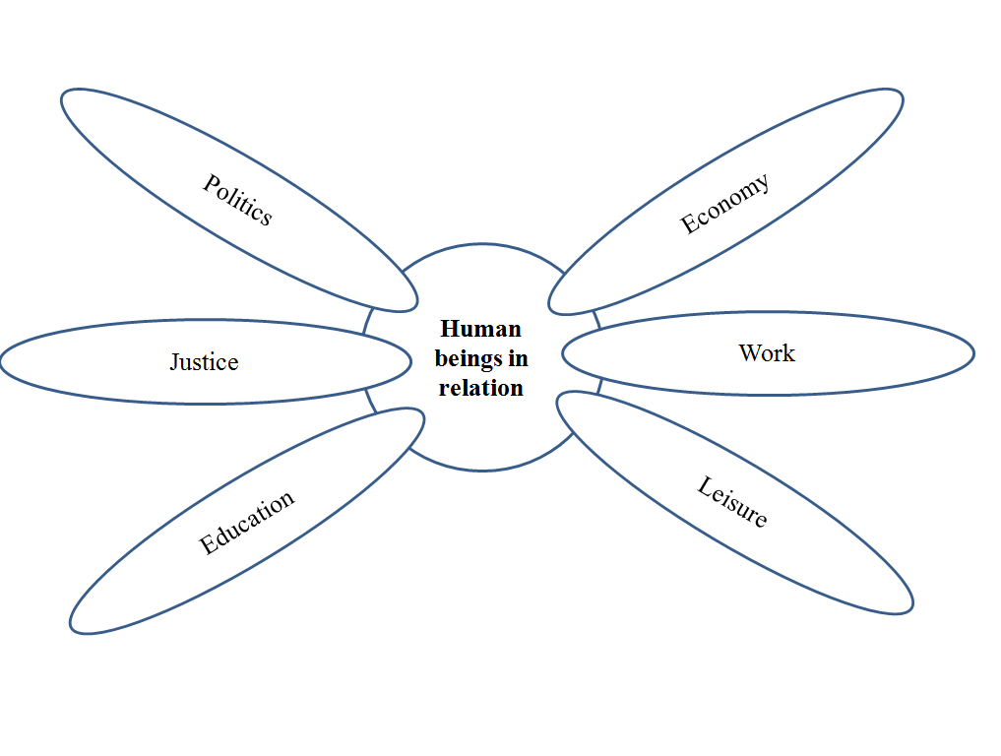

3.2.1. Pole of education
Education is based both on an institutional and non-institutional contingent, formal, informal and even non-formal, and is thought throughout the life of the human being: "training, [...] education cannot be completed after school and professional studies, that it is marked irreducibly by incompleteness" (Colin & Le Grand, 2008). It aims in a more or less conscious way the development of one or more dimensions of the person, the formation of oneself through learning (i.e., academic, psychomotor, books), updating of school skills, professional or simply personal. Education is considered as a preponderant element, not only to the development of the human being, and its social aspect, as mentioned above, but also as an essential factor of good living. Rousseau testifies to education as bringing the person not only to "live" in a functional way in any society whatsoever, but to live "happy" (Rousseau, 1762). Education makes it possible to develop, on the one hand, the consideration of the citizen towards his colleagues and, on the other hand, the privileged contact, which is possible for him to maintain with the institutions (in the most general sense of the word) of the company to which he belongs.

3.2.2. Pole of leisure
Leisure is perceived not as a necessity induced by our inability to work constantly (Durkheim, 1925). Free time is defined here, outside the boundaries of work and training, daily activities, personal and social obligations, and any activity of pure rest where only the action of doing nothing is sought. Foundations of access to leisure are rooted in the Declaration of Human Rights. Recalling that every human being has the right to rest and leisure, Dumazedier reminds us that society, as well as human beings, evolve constantly and often at a great speed and that, as a result, the leisure activity "allows to freely develop the skills acquired at school, but constantly overwhelmed by the continuous and complex evolution of society" (Dumazedier, 1962).

3.2.3. Pole of work
The concept of work can be perceived in different forms. The first, and the oldest, is the one that associates it with an activity that "mobilizes pain, effort, in a word work," (Deleule, 2001). The second, supported by Marx, among others, emphasizes, not on painful and harassing activity, but on developmental virtues. He also puts it forward in his analysis of the German theoretician: "Through work and the transformations it brings to the natural and social environment, man creates himself and creates the world" (Lê, 1991). The more contemporary conception of work is largely influenced by the gains, other than that of the final product, to which the worker has access. Participating in this system represents a social commitment, and allows everyone to live enjoying the fruits of everyone's work, an idea that is also reinforced by other authors (Hobbes, Thomas Aquinas).

3.2.4. Pole of economy
The mechanisms that come into play in the field of economics have undergone significant changes over the ages. The pole of the economy can be defined at present in its simplest form as that of "the production, the distribution and the circulation of wealth" (Dictionnaire d'économie et de sciences sociales, 2006) and, therefore, as a system that affects all citizens of a society and societies in general. Through the distribution and circulation of goods, the economy participates in providing for the primary needs of the members of society, an exchange that is a prerequisite to social life. From housing to food and clothing, goods circulate and help to ensure the livelihoods of people.

3.2.5. Pole of politics
The political pole describes a time and a place in which human beings must take part in the management of the society in which he evolves since "without political participation of the citizen democratic institutions are only skeleton" (Dubois, 2003). Participating in the establishment and, above all, updating this general way of conceiving the functioning of society gives the citizen political power. This power can be expressed in various forms: from thought to action, from awareness to dissemination, among others. The general framework in which we think of this type of power is that of democracy. The choice to refer to this type of regime represents, in our view and at the moment, the societal framework most suitable for every human being anxious to develop its social dimension by the favorable conditions it offers.

3.2.6. Pole of justice
Justice cluster offers the space for the elaboration of legislation, the framework of application legal acts and, finally, the place of interpretation and respect for these laws. The latter are of major importance because they represent the rights and thus necessarily the duties of all entities present in society: natural persons, legal entities, joint ventures and others. Whether described as civil, natural, moral or legal, these laws are designed to respect, in a democratic regime, respect for human dignity, private property and social participation. Laws are tested in the functioning and development of the different entities present in society, but also in the relations they can maintain between them and, therefore, in the consequences that underlie them. Thus laws can be interpreted, modified and adjusted in these contexts in order to preserve a space favorable to the optimal development of the person, whether they intervene directly or not on the latter.

3.3. Anchoring the ecological approach of Bronfenbrenner
The constitutive elements of our research emergent categories of our readings crystallized from contemporary authors and took shape within a dynamic structure: Bronfenbrenner's ecological approach (1979). This conceptual framework makes it possible to arrange the elements related to the development of the person, as much as to reveal the links and the reciprocal influences (Figure 3). The ecological environment to which Bronfenbrenner refers is detailed in four systems: microsystem, mesosystem, exosystem and macrosystem. These systems make it possible to consider a way of structuring the various social contexts in which the developing person lives the ontosystem both in their content and in the links that unite them. 1) Microsystem: "is a dynamic of activities, roles and interpersonal relationships experienced by the developing person in a setting with particular physical and material characteristics" (Bronfenbrenner, 1979). 2) Mesosystem: is the "set of [links] and processes that take place between two or more microsystems" (Bronfenbrenner, 1977). 3) Exosystem: is the "place or context in which the individual is not directly involved, but which nevertheless influences his life" (Bronfenbrenner, 1977). 4) Macrosystem: is the set of "contexts of development [...] composed of traditions, values, beliefs of society" (Berger, 2000). Also, 5) Bronfenbrenner talks about an additional system in his model, the chronosystem, linked to the passage of time. All these systems, linked to the environment or the individual, are the object of reciprocal interactions that influence the development of the person: "Development is the result of continual and reciprocal interactions between the individual organism and its environment" (Bronfenbrenner, 1979).

Figure 3.
Towards the development of social dimension of the human being in democratic society
- Bronfenbrenner's ecological environment.
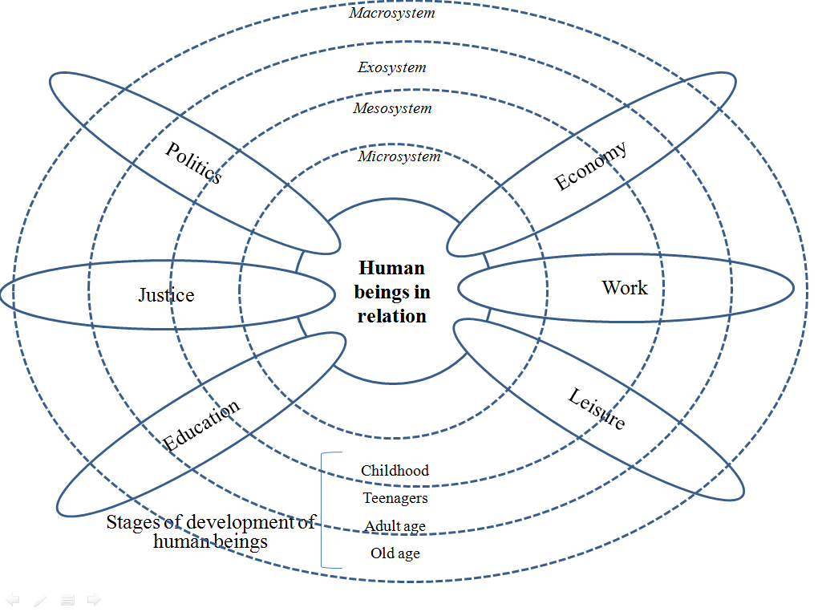

3.4. Environments: permanence and transversality within the social dimension of human beings
The work of modeling the concepts of the social dimension of human beings leads us to relate them to different environments immanent to any society (Figure 4). These become the spaces of unavoidable experimentation in which the individual will develop his social dimension in contact with the specific elements of these environments.

Figure 4.
Towards the development of social dimension of the human being in democratic society
- The model and its dynamics.

3.4.1. A human environment: the family
Whether it is part of a religious or secular, monarchical or democratic context, the family seems to be a cornerstone of establishing the foundations of these contextual dynamics. Whatever the period of history in which the family system developed, it was always used as a place of vectorization of the dominant values of contemporary societies, their customs and traditions. In addition, the dynamics between the different actors of the family tend to be transformed. Godard also tells us that by "introducing the idea of the relationship between generations we go beyond the somewhat mechanistic model of transmission, understood as a continuous flow of goods, values or knowledge going one way from the oldest to the youngest, donors to recipients and introduce the dynamics of historical relationships between generations" (Godard, 1992). In other words, within the family system, each member can exert influence on others by way of apprehending their history, to live their contemporaneity and to project themselves into the future.

3.4.2. A physical environment: natural and artificial
The presence of a physical environment is essential to the human being at all times and in all places. Therefore, this context accompanies the individual throughout his life and spreads in other social contexts. To consider the physical environment is to conceive of contexts of a natural order; that is to say, which do not belong to what the human being could have built, but also of an artificial order to say what he could build, transform, shape. The physical environment is, first and foremost, an indisputable base for the survival of human beings. The primary functions of our organization are largely ensured through the resources of our environment: air quality, water quality, access to food, etc. Moreover, and beyond survival, the well-being of human beings also depends on it. In the social development grid, the physical environment must be considered as a major element for which the person should be able to recognize his responsibilities, the actions that he can take, as well as the rights he has to his respect.

3.4.3. A cultural environment
UNESCO has drafted a definition of culture and thus considers it, "in its broadest sense, as the set of distinctive, spiritual and material, intellectual and emotional traits that characterize a society or social group. It includes, besides the arts and letters, lifestyles, the fundamental rights of the human being, value systems, traditions and beliefs" (Stanley, 2006). In this research, the importance is given to a culture in motion in which the elements form a "complex and interactive" whole (Stanley) that gives it a permanent development. Moreover, what confers this movement on the cultural environment is, in addition to a so-called general, dominant or dominant culture, the minor cultures that are also called subcultures (Bernier & Laflamme, 1994).

4. DISCUSSION

This model of social dimension of the human being describes the elements that emerged from our research, and their interrelationships, taking up the dynamics of Bronfenbrenner's ecological approach: A) In the centre of the figure is placed "the human being in relation" so as to recall that the anchor point of this research is the human being with its affective, cognitive and behavioural characteristics, that the latter is in relation with a social universe, both personal and shared with others, ultimately bringing together personal relationships, poles and social environments. Therefore, this "human being in relation" is, first and foremost, in a more or less direct way, with the other people they meet, whom they meet, or simply knows they exist. B) The human being evolves within a particular social universe and permanent and transversal environments. These three environments family, physical and cultural unfold in one form or another in the daily life of the individual from the first to the last moments of their existence. They offer permanence within the microsystem of human beings, in a more or less marked way, and diffuse through the other elements. C) Second category includes the six petals: education, leisure, work, the economy, politics and justice. They unfold from the microsystem (the person in relation) to the macrosystem of the human being that is translated by the contemporary democratic society in which they evolve. All the poles are, in turn, under the influence of others and are reorganized according to the changes taking place within each of them, but also, on a larger scale, in society in general, or even in external companies. D) At the ends of each petal, we find concentric dashed circles that represent the other characteristics of Bronfenbrenner's ecological approach and that conceptualize the dynamic relationship between the person and their environment to contribute to their development. These systems thus cut across each pole and each environment, and indicate, in each of them, that the human being is more or less directly interacting with their constituent elements. E) Straight vertical dashed lines represent the broadening of knowledge, skills, abilities, motivations and others that evolve with the individual's stages of development. F) Finally, if this model is realized under the guise of a contemporary democratic society, it remains nonetheless that it is also influenced by other societies. The white arrows pointing inward and outward of society once again show the dynamics of exchanges between societies in general and between the different elements that compose them in particular.
The main limitation of this research lies in the model itself that we propose, and comes in three aspects. First, the model is open; that is, it can and should be subject to change. This characteristic is peculiar to the inductive methodology of Grounded theory (Glaser & Strauss, 1967) who considers that the model thus created must always be perceived as a developing entity and not as a perfect, finished product. Secondly, the historico-cultural study of the human being and Western societies was, at first, limited to a certain number of authors and works consulted. Therefore, the list developed is not exhaustive and the summary tables of the authors and their thoughts is a tool that allows one to mark out a continuation of this work by specialists from each scientific field in order to synthesize knowledge and to offer a complex, up-to-date understanding of human beings and the elements that lead to their optimal development. Therefore, it would be interesting to enrich certain notions through the study of authors we have not selected or vis-à-vis texts that we have not read to build this basic model of the social dimension of human beings. It should also be noted that if the wish here was to raise recurring concerns among the ancient authors when they touched on issues related to citizenship, the virtuous man or the social aspect of the person, by, for example, some researchers met during the selection phase of thinkers took a cautious look at the mechanism of our research. Indeed, they argued that thinkers took positions in particular times and contexts, and in most cases were far removed from current societal, technological, scientific and cultural characteristics, among others. Thirdly, another aspect of the research boundary is that human beings and the societies in which they evolve are in constant transformation, a model of the development of their social dimension must accompany them in their emancipation. As interesting as this model is of social development that we are currently proposing, it will not be less lacunary, or even partially wrong, in the near future.

5. CONCLUSION

The construction of this model responded to the desire to collect and synthesize the largest number of constitutive elements about the social dimension of human beings, a construction site still too fragmented. If several studies are interested in the process of socialization of individuals to make them "functional citizens," little interest in circumscribing all the constitutive elements of the social dimension from a developmental perspective of the person to tend, deliberately towards higher levels of humanity.
This chapter has also clarified the concept of social development of human beings. Indeed, the term "social dimension" refers on the one hand to the reality of the daily interpersonal relationships of the person perceived as a unique universe to each within the six dominant poles identified and the three permanent transversal environments. On the other hand, the social dimension calls for another reality that is no longer based simply on contextual or conceptual elements, but on their dynamic relationships that contribute to the development of the person, relations between these elements, but also with the person itself. This ambitious research project has become more than necessary as several authors have shown (Fortin, 2007; Legendre, 2002; Marcotte, 2015; Morin, 2000, 2011). Not only must the characteristics of the human being be studied and articulated together, but more than that, they must target the improvement of human development to truly take a step closer to a more humanizing education that goes beyond the instruction. A future step would be to make this tool applicable to the reading of the current reality and this, in several contemporary social contexts. Humbly, we are now inviting other specialists in the social dimension of human beings and related themes or issues to pursue, revisit and enrich this work so that it can achieve the ambition it sets for itself. The path is still long, but if the human efforts meet around a clear target and are well oriented, the march will be faster.

REFERENCES

Bee, H., & Boyd, D. (2003). Lifespan Development. Toronto: Pearson.
Berger, K. S. (2000). The Developing Person through the Life Span. New York, NY: Worth Publishers.
Bernier, C., & Laflamme, S. (1994). Être un être social. Montréal: Guérin.
Bronfenbrenner, U. (1977). Toward an Experimental Ecology of Human Development. American Psychologist, 32(7), 513-531.
Bronfenbrenner, U. (1979). The Ecology of Human Development: Experiment by Nature and Design. Cambridge, MA: Harvard University Press.
Colin, L., & Le Grand, J.-L. (2008). L'éducation tout au long de la vie. Paris: Anthropos.
Comte-Sponville, A. (1995). Petit traité des grandes vertus. Paris: PUF.
Consortium on the School-based Promotion of Social Competence. (1994). The School-based Promotion of Social Competence : Theory, Research, Practice and Policy. In R. J. Haggerty, L. R. Sherrod, N. Garmezy, & M. Rutter (Eds.), Stress, Risk, and Resilience in Children and Adolescents (pp. 268-316). New York, NY: Cambridge University Press.
Deleule, D. (2001). Anthropologie et économie chez Hume : la formation de la société civile. In C. Gautier (Ed.), Hume et le concept de société civile (pp. 19-48). Paris: PUF.
Dictionnaire d'économie et de sciences sociales. (2006). Économie. Paris: Nathan.
Dubois, J.-P. (2003). Démocratie et citoyenneté. In J.-P. Dubois & M.-C. Vergiat (Eds.), Refonder la citoyenneté : démocratie politique & démocratie sociale (pp. 9-34). Latresne: Le Bord de l'eau.
Dumazedier, J. (1962). Vers une civilisation du loisir ? Paris: Seuil.
Dupuy, B. (2010). Le développement social de la personne. Identification et justification des éléments fondamentaux. (Master), Université Laval, Québec.
Dupuy, B., Boileau, R., & Gadais, T. (2019). Human being development: research protocol for a holistic and complex review on the social dimension. Education New Development 2019, Vol II, 274-276.
Durkheim, E. (1925). L'éducation morale. Paris: PUF.
Fortin, R. (2007). Comprendre l'être humain : pour une vision multidimensionnelle de l'être humain. Québec: Éditions DÉPUL.
Gadais, T., Rioux, M.-A., & Boileau, R. (2019). Human beings development through holistic and complex approach. Education New Development 2019, Vol II, 71-75.
Glaser, B. G., & Strauss, A. L. (1967). The Discovery of Grounded Theory: Strategies for Qualitative Research. Chicago, IL: Aldine Publishing.
Godard, F. (1992). La famille, affaire de générations. Paris: PUF.
Huchon, J.-P. (2002). L'être social. Paris: L'Harmattan.
Lê, T. K. (1991). Marx, Engels et l'éducation. Paris: PUF.
Legendre, R. (2002). Stop aux réformes scolaires : pour dénouer la crise maintenant! Montréal: Gaetan Guérin.
Marcotte, G. (2015). Les fondements de la dignité humaine et de cinq nouveaux droits. Québec: Éditions Humanisation.
McHugh, E. (1995). Going « beyong the Physical » : Social Skills and Physical Education. Journal of Physical Education, Recreation & Dance, 66(4), 18-24.
Ministère de l'Éducation du Loisir et du Sport. (2004). Programme de formation de l'école québécoise : enseignement secondaire, premier cycle. Québec: Ministère de l'éducation.
Morin, E. (2000). Les sept savoirs nécessaires à l'éducation du futur. Paris: Seuil
Morin, E. (2011). La Voie: Pour l'avenir de l'humanité. Paris: Fayard.
O'shea, K. (2003). Comprendre pour mieux se comprendre. Glossaire des termes de l'éducation à la citoyenneté démocratique. Retrieved from http://www.coe.int/DefaultFR.asp
Papalia, D. E., & Olds, S. W. (1989). Human Development. New York, NY: McGraw-Hill.
Parmentier, M. (2002). Le vocabulaire de Locke. Paris: Ellipses.
Raveaud, M. (2006). De l'enfant au citoyen : la construction de la citoyenneté à l'école en France et en Angleterre. Paris: PUF.
Rinn, R. C., & Markle, A. (1979). Modification of Social Skills Deficits in Children. In A. S. Bellack & M. Hersen (Eds.), Research and Pratique in Social Skills Training (pp. 107-130). New York, NY: Plenum.
Rousseau, J. J. (1762). Émile, ou de l'éducation. Paris: Nicolas Bonaventure Duchesne.
Royer, N. (1982). L'enfant en développement social et affectif. Rimouski: Département des sciences de l'éducation, UQAR.
Stanley, D. (2006). Recondita armonia : réflexions sur la fonction de la culture dans la construction de la citoyenneté. Strasbourg: Éditions du Conseil de l'Europe.

AUTHOR(S) INFORMATION

Full name: Bertrand Dupuy, M.A.
Institutional affiliation: Department of Physical Education, Cégep de St Hyacinthe
Institutional address: 3000, avenue Boullé, Saint-Hyacinthe (Québec), J2S 1H9, Canada
Short biographical sketch: Bertrand is a professor of physical education at CEGEP St Hyacinthe. He holds a master's degree (M.A.) in psychopedagogy from Laval University for his work of literature review on the social dimension of the human being in a holistic perspective.

Full name: Roger Boileau, Ph.D
Institutional affiliation: Département d’éducation physique, Université Laval
Institutional address: Pavillon de l'Éducation physique et des sports, 2300 Rue de la Terrasse
Québec (Québec), G1V 0A6, Canada
Short biographical sketch: Roger Boileau is an associate professor in the Department of Physical Education at Laval University. He is a specialist in sociological aspects of physical activity and sport. He is the editor of Département d’éducation physique de l’Université Laval (DEPUL).

Full name: Tegwen Gadais, Ph.D
Institutional affiliation: Département des sciences de l’activité physique, Université du Québec à Montréal
Institutional address: 141, Avenue du Président Kennedy, Montréal (Québec), H2X 1Y4, Canada
Short biographical sketch: Tegwen Gadais has taught physical education in several French educational institutions, with varying levels and clientele. He also has expertise in the field of international cooperation and development where he continues to work with various organizations in developing countries. Her current research focuses on the topics of physical education, health education, outdoor physical activity and the outdoors; sport, physical activity and international development as well as human development in a holistic approach.

